Due: 10/15 (B day) & 10/16 (A Day)
Details: As you are reading the “Ill-made Knight” Section of The Once & Future King pay attention to the character traits and accomplishments of Arthur’s Knights of the Round Table. Which of the following knights would be your friend or your foe?

- King Pellinore
- Lancelot
- Gareth
- Gawaine
- Agravaine
- Galahad

This is a chance for us to get to know WHO YOU ARE as well, what kind of knight are you and what sparks your motivations. You will be creating EITHER a 3D Shield or a Printed Family crest.

Key Things to Consider (you should review fleurdelis.com for reference):
- Shape: Classic, Continental, Angled, Edged, Elegant, Ornate, Roman, Spartan; there MANY
- Size: Varies
  - 3D Shield, must be proportionate to the student
  - Coat of Arms must be a FULL PAGE 8 ½ x 11 FULL COLOR Printing
- Colors: Favorite or symbolic colors
- Mark of Cadency: What is your Birth order? Oldest, middle, youngest
- Symbols: What are your favorite things? Represented in classical design or modernized
- Motto: Find one that suits you in Latin, French, or Spanish
- Mantling (optional): decorative design around the shield
- Supporters (optional)-Animals or people that “hold up” the shield

Examples:
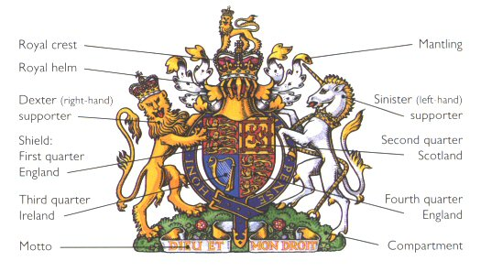
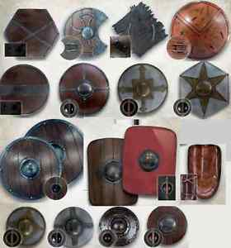
Family Crest Student Personalized Shield

Written Explanation:
100-250 word analysis of your connection to the Knight of your choice from Arthur’s Round Table as well as detailed discussion on your shield elements; attach this to the back of the shield (recommend doing it on a 5x8 card).

