- Open in NEW Document
- Turn on the “Show Hide” Button, then… 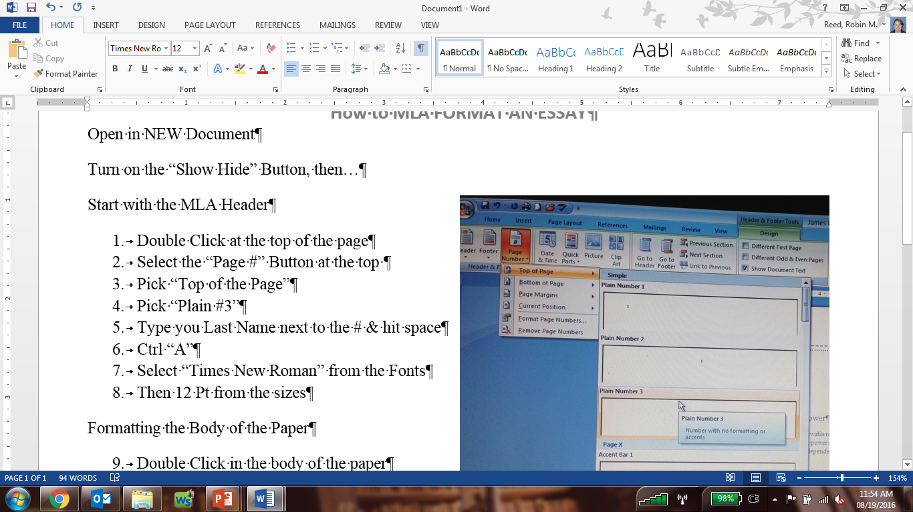
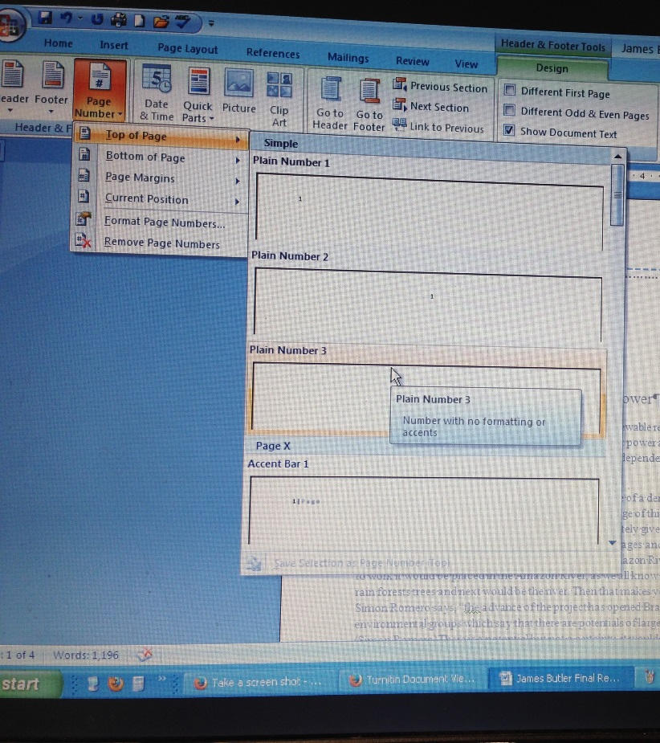
Complete the MLA Header
- Double Click at the top of the page
- Select the “Page #” Button at the top
- Pick “Top of the Page”
- Pick “Plain #3”
- Type you Last Name next to the # & hit space
- Ctrl “A”
- Select “Times New Roman” from the Fonts
- Then 12 Pt from the sizes
Formatting the Body of the Paper
- Double Click in the body of the paper
- Check your Margins:
  - “Page Set-up”
  - “Normal” or 1” Margins
- Check that you are DOUBLE SPACED
  - CRTL + A
  - CRTL + 2
- Check your Font is 12 PT Times New Roman
  - CRTL + A
  - Adjust font size & style on the tool bar
- Type in the Following
  - Your Name
  - Mrs. Reed
  - The Class & Period
  - The Date: Day Month Year
- New Line, Type your Title for the Assignment
  - Centered (CRTL + E)
  - SAME FONT/SIZE, etc
  - Make it Creative, not just the title of the assignment!
  - NO Punctuation in a Title, no ! or ? or …
- Hit enter & then LEFT Align the cursor
- TAB in 1 time to begin your paragraph
- DONE!

