The Hippie Counter Culture Movement (1960’s)
BY BHADDOCK · PUBLISHED MARCH 9, 2011 · UPDATED APRIL 12, 2014
The 1960’s are defined by the hippie counter-culture craze that invaded the lives of every citizen in the United States and around the world.

What were hippies and their counter-culture movement?
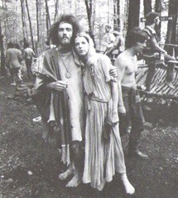
The 1960’s hippie counter culture movement involved a variety of social concerns and beliefs. The hippies’ primary tenet was that life was about being happy, not about what others thought you should be. Their “if it feels good, do it” attitudes included little forethought nor concern for the consequences of their actions. Hippies were dissatisfied with what their parents had built for them, a rather strange belief given that their parents had built the greatest booming economy the world had ever seen.
Hippies rejected established institutions. Calling them “The Establishment”, “Big Brother”, and “The Man”, hippies believed the dominant mainstream culture was corrupt and inherently flawed and sought to replace it with a Utopian society.
Hippies rejected middle class values, opposed nuclear weapons and the Vietnam War. They embraced aspects of eastern philosophy and sought to find new meaning in life.
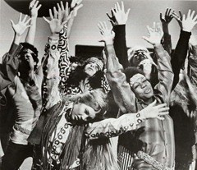
Hippies were often vegetarian and believed in eco friendly environmental practices. They championed free love and sexual liberation, particularly for women. They also promoted the use of psychedelic drugs which they believed expanded their consciousness.
Hippies participated in alternative arts and street theater and listened to folk music and psychedelic rock as part of their anti-establishment lifestyle. They opposed political and social violence and promoted a gentle ideology that focused on peace, love, and personal freedom. Some hippies lived in communes or aggregated communities of other hippies. Some described the 1960’s hippies movement as a religious movement.
Hippies created their own counter culture founded on psychedelic rock and the embracement of the sexual revolution. Drugs such as marijuana and LSD were tightly integrated into their culture as a means to explore altered states of consciousness. Contrary to what many believe, hippies tended to avoid harder drugs such as heroin and amphetamines because they considered them harmful or addictive.
Hippie dress, which they believed was part of the statement of who you were, included brightly colored, ragged clothes, tie-dyed t-shirts, beads, sandals (or barefoot), and jewelry, all of which served to differentiate them from the “straight” or “square” mainstream segments of society. Their aversion to commercialism also influenced their style of dress. Much of their clothing was often purchased at flea markets or second hand shops.
Hippie men wore their hair long and typically wore beards and mustaches while the women wore little or no makeup and often went braless (occasionally shirtless).
The peace symbol became the hippie official logo and the VW bus their official means of group transportation. Hippies often drove VW buses painted with colorful graphics so they could quickly pack up and travel to where the action was at any given time. Their gypsy like travel habits also meant many hitchhiked to get to and from major hippie events.

History of hippies and the counter culture movement
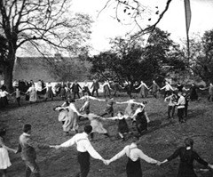
The origin of the word “hippie” derives from “hipster” which was first coined by Harry Gibson in 1940 in a song titled “Harry the Hipster” (as Harry referred to himself). In the song, hipsters were beatniks who had moved into New York City’s Greenwich Village. Beatniks were followers of the Beat Generation literary movement who through their writings, promoted anti-conformist attitudes and ideals. The first clearly used instance of the term “hippie” occurred on September 5, 1965 in the article “A New Haven for Beatniks” by San Francisco journalist Michael Fallon (who was writing about the Blue Unicorn coffeehouse).
Similar counter culture movements had occurred in Germany between 1896 and 1908. Known as Wandervogel (which translates roughly to “migratory bird”), the youth movement arose as a countercultural reaction to the urbanization that was occurring in Germany at the time. Wandervogel youth opposed traditional German values and forms of entertainment and instead emphasized amateur music and singing, creative dress, and communal outings involving hiking and camping. They were a back-to-the-earth generation who yearned for the simple, sparse, back-to-nature spiritual life of their ancestors.
In later years, the Wandervogel Germans immigrated to the United States where they opened many West Coast area health food stores. Many moved to Southern California. Over time other Americans adapted the beliefs and practices of the Wandervogel youth. Songwriter Eden Ahbez wrote a hit song called Nature Boy that was inspired by the Wandervogel follower, Robert Bootzin. The song helped popularized health consciousness, yoga, and organic food throughout the United States.

The Beat Generation and Beatniks
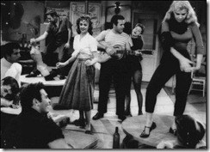
Following the Wandervogel youth movement, the 1950’s introduced the “Beat Generation” to the United States. The Beat Generation were a fringe group of American writers who came to prominence in the 1950’s. Allen Ginsberg’s Howl (1956), William S. Burroughs’s Naked Lunch (1959) and Jack Kerouac’s On the Road (1957) are among the best known examples of Beat literature. Because of their explicit descriptions of homosexual sex (many of the central Beat Generation authors were openly homosexual), the books Howl and Naked Lunch became the focus of United States obscenity trials. Ultimately the results of the trials helped to liberalize publishing in the United States.
The term “beat” came from “tired” or “beaten down” which is how the Beat Generation described their era. Followers of the Beat Generation came to be known as “beatniks”, a combination of the words “Beat Generation” and the recently launched Russian satellite Sputnik (Sputnik used in the collective because it was “far out of mainstream society”).
Central elements of the “Beat” were drug experimentation and alternative forms of sexuality (particularly homosexuality), an interest in Eastern religion, and a general rejection of materialism. Beatniks soon developed a reputation as bohemian hedonists who celebrated non-conformity and spontaneous creativity.
A large number of beatniks moved from New York City to San Francisco in the late 1950’s and became in integral part of the upcoming hippie counter culture movement.

The hippies arrive in California
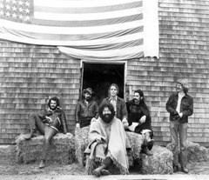
Chandler A. Laughlin II, cofounder of the infamous Cabale Creamery club in Berkeley, was greatly influenced by the Beat Generation and their beatnik culture. In 1963, Laughlin followed their lead and established a tight family-like identity among 50 people in Greenwich Village in New York City and later Berkeley, California. Laughlin recruited many of the early psychedelic musical talent acts including the Grateful Dead, Jefferson Airplane, Iron Butterfly, The Charlatans, and others. Laughlin and George Hunter of The Charlatans band, were true “proto-hippies” wearing long hair, boots, and outrageous clothing. Together they opened the Red Dog Saloon in the old mining town of Virginia City, Nevada. The Red Dog Saloon became a focal point of drugs and psychedelic music festivals.
During this time, LSD manufacturer Owsley Stanley, who also lived in Berkeley, provided much of the LSD to the burgeoning hippie scene. Stanley, an ex-army radar operator, converted his amphetamines lab to an LSD lab and became one of the first millionaire drug dealers in the United States. His LSD product became a part of the “Red Dog Experience”, the early evolution of psychedelic rock and the budding hippie culture. At the Red Dog Saloon, the Charlatans were the first psychedelic rock band to play live while high on LSD.

The Red Dogs move to San Francisco
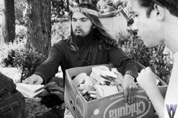
In October of 1965, many Red Dog participants returned to their native San Francisco where they created a new collective called “The Family Dog”. On October 16, 1965, The Family Dog hosted “A Tribute to Dr. Strange” at the Longshoreman’s Hall in San Francisco. The event was the first psychedelic rock performance in San Francisco. Over 1,000 “hippies” attended to watch Jefferson Airplane perform alongside a rudimentary dance and light show. Additional psychedelic rock shows followed, including the infamous January 22, 1966 Grateful Dead performance where 6,000 people were given punch spiked with LSD and treated to the first fully-developed, elaborate light show.
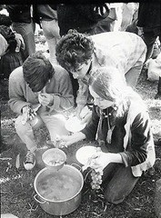
As attendance exploded at the psychedelic rock shows, The Family Dog became Red Dog Productions and event locations were expanded. More performance/parties were held at venues such as the Avalon Ballroom and the Fillmore Auditorium. These shows were full psychedelic musical experiences with light shows combined with the colorful film projections that became the staple of the 1966’s hippie events. Event attendees often wore colorful, outlandish costumes to these shows.
By June of 1966, San Francisco’s Haight-Ashbury district was the epicenter of the hippie movement. The area was already primed to become the center of hippie activity as its residents consisted of beatniks, writers, artists, and musicians. About 15,000 hippies had moved to the area including the psychedelic bands The Charlatans, Jefferson Airplane, Big Brother, and Holding Company. The hippies accepted into their family the performance group The Diggers, a street theater group who combined spontaneous street theater with anarchistic action and art happenings. The Diggers sought to build an alternative free society where every need and desire could be obtained for free. By late 1966, The Diggers had opened public stores that provided free food (some of which was stolen off the backs of trucks), distributed free drugs, gave away money, and organized music concerts and art events.
In October 1966, California became the first state to make LSD illegal when they declared LSD a controlled substance. In response to the criminalization of their psychedelic drug, San Francisco hippies staged a gathering in the Golden Gate Park. The event was called the Love Pageant Rally. The purpose of the event was to demonstrate that those who used LSD were not evil, criminals, or mentally ill. It was the first incidence of political activism initiated by the hippies. Drugs were handed out to participants and the hippies put tabs of LSD on their tongues in front of police in protest of the new law.

The Summer of Love
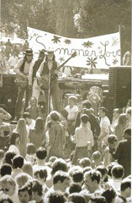
On January 14, 1967 the Human Be-In event was held in Golden State Park in San Francisco. This event, which received extensive media coverage from the major networks, popularized the hippie culture throughout the United States and led to the legendary Summer of Love on the West Coast. Three thousand hippies were expected but thirty thousand hippies showed up and gathered in San Francisco’s Golden Gate Park to celebrate the hippie culture. The Diggers secretly slipped LSD into the free turkey sandwiches that were handed out to all attendees and the media was treated to an all-out drug exhibition as drug addled hippies danced and sang before the cameras. Three months later, on March 26, 1967, 10,000 hippies came together in Manhattan for the Central Park Be-In.
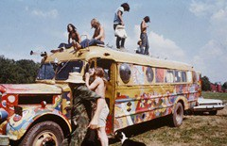
Scott McKenzie’s rendition of the John Phillips’ song, San Francisco, became a huge hit in the United States and Europe. One lyric, “If you’re going to San Francisco, be sure to wear some flowers in your hair” inspired thousands to travel to San Francisco, many wearing flowers in their hair and distributing flowers to passerby at intersections and on the street. The name “Flower Children” stuck.
Articles about the hippie movement appeared in prominent mainstream magazines including Time Magazine who ran the story, The Hippies: The Philosophy of a Subculture. The Time magazine cover story described the guidelines for being a hippie:
“Do you own thing, wherever you have to do and whenever you want. Drop out. Leave society as you have known it. Leave it utterly. Blow the mind of every straight person you can reach. Turn them on, if not to drugs, then to beauty, love, honesty, and fun.”
It has been estimated that 100,000 people travelled to San Francisco during the summer of 1967. The media followed the movement of the hippies casting a spotlight on the Haight-Ashbury district where many of the psychedelic bands lived and played. In the hippies’ eyes, they had become freaks and little more than a sideshow for the amusement of visiting tourists. Many began to flee Haight in search of calmer, more remote settings.

The death of the hippie
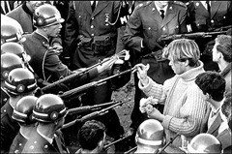
At the end of summer 1967, The Diggers declared the “death” of the hippie movement and burned an effigy of a hippie in Golden Gate Park. The Haight-Ashbury scene had deteriorated dramatically. The Haight Ashbury district simply could not accommodate the influx of hundreds of thousands of hippies. Many hippies, some no older than teenagers, took to living on the street, panhandling, and drug dealing. Problems such as malnourishment, disease, and drug addiction grew prominent in the Haight community. Crime and violence in the area skyrocketed as homeless drug addicted hippies stole to survive and drug dealers moved in to control the drug trade. By the end of 1967, many of the hippies and musicians who initiated the Summer of Love moved on, leaving many misgivings about the hippie culture, particularly with regards to their drug abuse and lenient morality.
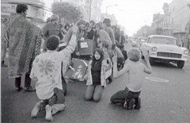
Although the hippie movement died in Haight, it was still alive in the United States and moving eastward. By 1968, the movement continued to cross the country. Hippie fashion trends spread into the mainstream, especially popular with young teenagers and young adults of the populous “Baby Boomer” generation. Longer hair for men, beads, feathers, flowers, and bells were worn by many teenagers of the era even though they did not necessarily delve deep into the hippie culture or the hardcore hippie beliefs that were prominent from 1966 through 1967. The movement even spread overseas to Britain and Australia.
Around this time, the hippie movement began to take on dire meaning to the mainstream public. The “Yippies”, led by Abbie Hoffman and Jerry Rubin, were notorious for their theatrics. The Yippies tried to levitate the Pentagon at an October 1967 war protest. They used the slogan, “rise up and abandon the creeping meatball”. Civil disobedience was encouraged – over 3,000 took over Grand Central Station in New York resulting in 61 arrests. They even nominated their own candidate for the 1968 Democratic National Convention in Chicago – Lyndon Pigasus Pie (an actual pig). Their silly theatrics were unpopular and looked down upon by the mainstream public who generally wanted a country governed by law and order.

People’s Park – the hippie era turns violent
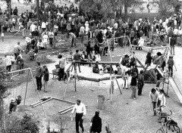
In April 1969, citizens, including many hippies, were disgusted with the decrepit conditions of a vacant lot on the University of California campus. The university had taken the homes of area residents through eminent domain and demolished all buildings on a 2.8 acre lot. The lot was subsequently ignored by the University and became quite an eyesore for the neighborhood. Partially demolished buildings, debris and rubble were scattered throughout the lot. Eventually people began dumping old abandoned cars on the empty lot until it became a sort of junk yard.
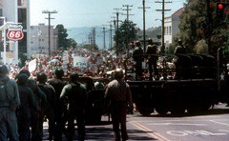
Citizens, including hippies, took matters into their own hands and planted trees, shrubs, flowers, and grass to convert the vacant lot into a park which they affectionately named People’s Park. The radical form of political activism was frowned upon by the authorities. Reagan, already angered that the University allowed student demonstrations, called the Berkeley campus “a haven for communist sympathizers, protesters and sex deviants.” A major confrontation occurred one month later when on May 15, 1969 Governor Ronald Reagan ordered the park destroyed and a protective chain link fence built around it to keep people out. Riots quickly followed as students attempted to “take back the park”. The police were called in and over 128 Berkeley residents were taken to area hospitals for head trauma, shotgun wounds, and other serious injuries inflicted by the police. One student was killed by a police shotgun blast and another man permanently blinded. This led to a two week occupation of Berkeley by the United States National Guard after Reagan called a state of emergency.
During the National Guard occupation, students snuck into the park at night and planted flowers. Each morning the National Guard destroyed all flowers that had been planted the night before. Police were caught parking their vehicles several blocks away from the park and ironically, donning pig Halloween masks, attacking citizens that they found near the park. A year later, similar violence would erupt at Kent State University, killing four students and seriously wounding nine.
“These differing perspectives mirrored widespread 1960s societal tensions that tended to flow along generational lines regarding the war in Vietnam, race relations, sexual customs, women’s rights, traditional modes of authority, experimentation with psychedelic drugs and opposing interpretations of the American Dream. “ A wall began to form between the hippies and the general public.

Woodstock ends the hippie era
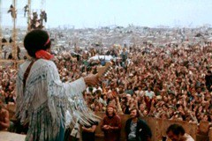
The gap that existed between the hippies and mainstream society widened. In August 1969, 500,000 people attended the Woodstock Music and Art Fair in Bethel, New York. Bands at the event included Joan Baez, Janis Joplin, Grateful Dead, Creedence Clearwater Revival, Crosby, Stills, Nash and Young, Carlos Santana, The Who, Jefferson Airplane, and Jimi Hendrix. The Wavy Gravy Hog Farm provided security for what was a mostly peaceful event. The mainstream public was treated to visuals of drug using hippies covered in mud and exhibiting bizarre behavior.
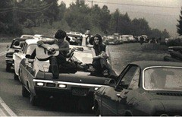
In that same month, Sharon Tate (and her unborn baby) and Leno and Rosemary LeBianca were murdered by Charles Manson, a former Haight-Ashbury resident, and his “followers”, who the public identified as drug crazed hippies.
Counter culture catastrophes continued. In December 1969, 300,000 people attended the Altamont Free Concert where the Rolling Stones, Crosby Stills Nash and Young, and Jefferson Airplane played. The Hells Angels provided security for the event. 18 year old African American Meredith Hunter was stabbed and killed during the Rolling Stones performance.
By 1970, the hippie movement began to wane. The events at the Alatamont Free concert shocked many people including some who had supported the hippie movement. Several hippie mega-stars, including Jimi Hendrix, Janis Joplin, and Jim Morrison, overdosed on drugs. The Charles Manson murders also contributed to the public hatred of the hippies. Soon, hippies were being physically attacked on the streets by skinheads, punks, athletes, greasers, and members of other youth subcultures.

The impact of the hippie movement
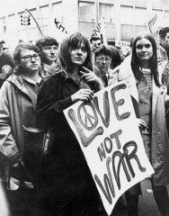
The impact, good and bad, of the 1960’s hippie movement cannot be denied. The movement influenced popular music, television, film, literature, and the arts. The music industry, particularly the rock music segment, experienced an explosion in sales that has continued to this day. In subsequent years, unmarried couples no longer felt persecuted for living together. Frankness regarding sexual matters was common. Religious and cultural diversity gained greater acceptance. Even fashion was impacted as the popularity of the necktie and other business apparel declined and was replaced by more casual dress standards.
Some changes were not as positive though. Some argue that the movement ushered in more liberal press and movies which has led to a degradation of our cultural values and ethics. Youth fashions became more and more bizarre , and sexual, in an attempt to rebel against the mainstream values. Some argue that the embrace of spontaneity and worship of the “primitive” have turned us towards mindlessness and violence.

