Scenario:
A ship is sinking, and you have managed to board a lifeboat with twelve other they are in street clothes. One woman is in a bathing suit. The ship is in the North Atlantic, the temperature is about 32 degrees Fahrenheit, and there are strong winds and high waves. The lifeboat has no motor, so it must be rowed. You may have to spend several days at sea depending on when the boat is spotted. The ocean is foggy with low, heavy clouds. The boat is dangerously overloaded so you must dump 60 pounds of weight. You must decide which items you will remove. For safety reasons, you may not suspend any items from the lifeboat. You may not remove any of the people.
These are the items from which you must choose:
- 5 slicker raincoats with hoods, each 2 lbs.
- 30 cans of tuna fish (flip tops), each 1 lb.
- a 2-gallon container full of water, 10 lbs.
- a battery-operated signal light, 8 lbs.
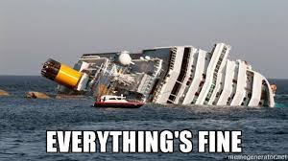
- 3 skin-diving wet suits, each 5 lbs.
- 2 buckets for bailing, each 3 lbs.
- 4 wool blankets, each 2 lbs.
- a large S.O.S. flag, 3 lbs.
- a first aid kit, 10 lbs.
- 8 oars, each 5 lbs.
Total—140 lbs.
Your Job:
Decide which items you will remove from the life boat. Remember it must be at least 60 pounds removed, no people may be removed, and nothing can be suspended from the boat.

