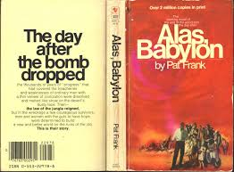
Set up Landscape Document
Set with 2 Columns

Part 1
Choose ONE question AND use a quote for support. Explain your points, sell this book!
- Describe your favorite part of the novel and why?
- Who is your favorite or least favorite character and why?
- Which event or situation made you the angriest, saddest, irritated or shocked?
Part 2 (Tagline)
Explain a specific theme (do not use character names or situations etc.) from your novel. Use one 4-10 word quote from the novel to illustrate this specific theme.

Part 3 (Primary Image)
This is a BIG picture that captures the essence of your novel. For example the novel “And the Mountains Echoed” do NOT use a picture of a mountain as your symbol. This is too literal. Create something abstract.
Explain how your symbol captures the essence of your book. Do not use people or words. (On the 2nd Page of the Document)

Please upload to Turnitin.com!

