Name_________________________________________________ Date______________ Period_______
BYRONIC HERO ROTATIONS
Rotation 1: Analyzing Mr. Gru from Despicable Me and Batman from The Dark Knight Rises
Directions: Watch the clips ( https://www.youtube.com/watch?v=89gr6dDlItE and https://www.youtube.com/watch?v=5U3jf8BRdE4 ) and answer the following questions.
- What characteristics about Gru are considered Villain (negative) traits?

- What characteristics about Gru are considered to be redeemable?

- What makes Gru a Byronic Hero?

- What characteristics about Batman are considered “dark”?

- What characteristics about Batman are considered to be redeemable?

- What makes Batman a Byronic Hero?

Rotation 2: Discovering Byronic Heroes in Popular Culture
Byronic Hero | Where is s/he from? | Traits of a Byronic Hero
Choose 1 of your characters from the chart and answer the following questions:
- What action does your character of choice do that makes him/her redeemable? Is this choice excusable in your opinion of the negative traits this character possesses? Why or why not?

- What is the significance of having this character in the novel/ movie/ show, etc? What would happen if this character had a total makeover in the personality and behavior categories? Would the novel/movie/show still be the same? Why or why not?

Rotation 3: Casting Call For Byronic Hero
You will create a casting call for the perfect lead BYRONIC HERO to star in the new motion picture:
NOT ONE OF THEM
An epic tale of a hidden heart behind a tough exterior.

A casting call outlines the actor/actress needs of a production. In other words, exactly the type of character the studio is looking to find. The information covers age range, gender, height range, weight range, notable physical features, main characteristics as to the insight of the character, special talents, and a short scene that would be in the movie to demonstrate what that character will do.

Complete the form below to craft the casting call for the BYRONIC HERO you think will be perfect in this role.

GENDER:____________ AGE:____________ HEIGHT:_________ WEIGHT:___________

NAME (of character):________________________________________________________________

PHYSICAL APPEARANCE (notable features):
_____________________________________________________________________________________
_____________________________________________________________________________________
_____________________________________________________________________________________
_____________________________________________________________________________________
_____________________________________________________________________________________
_____________________________________________________________________________________
_____________________________________________________________________________________
_____________________________________________________________________________________

CHARACTERISTICS of ROLE:
_____________________________________________________________________________________
_____________________________________________________________________________________
_____________________________________________________________________________________
_____________________________________________________________________________________
_____________________________________________________________________________________
_____________________________________________________________________________________

SPECIAL TALENTS:
_____________________________________________________________________________________
_____________________________________________________________________________________
_____________________________________________________________________________________
_____________________________________________________________________________________
_____________________________________________________________________________________

***SCENE: (Detail a short scene from the movie that will be used as an audition piece. This short storyboard with dialogue should encapsulate the key Byronic Hero Traits that would be seen in the movie. Sketch out the shots, write dialogue and describe the action that the character would do.):

Facing the camera, looking down, “I said, ‘Leave her alone.’ He looks up, brooding, making eye contact, and his eyes scream that he will follow up his statement with actions of violence.
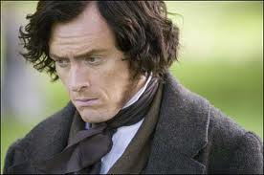
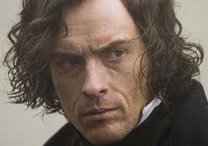

_______________________________________________________________________________________________________________________________________________________________________________________________________________________________________________________________________________________________________________________________________________________

_______________________________________________________________________________________________________________________________________________________________________________________________________________________________________________________________________________________________________________________________________________________

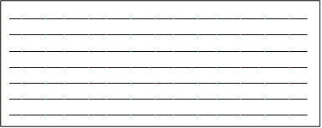

Rotation 4: Comparing Haymitch (Hunger Games), Edward Cullen (Twilight), and Holden Caulfield (Catcher in the Rye)


