Welcome to the “Who am I?” Intro Project for English III 2019-2020!
Summer Reading Assignment (As assigned last year-this is a direct Screenshot from the hand out given in English 2 AND Posted on the school Website)
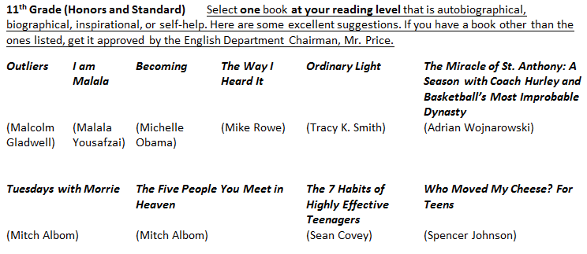
For this Project you will be answering one of the following questions:
- What about the title or prior knowledge of the author/subject matter piqued your curiosity and convinced you to select this book over all the others out there?
- What life lesson, message, or theme conveyed in this book resonates with you the most? In other words, why do you find this book inspiring? (examples: overcoming odds or discrimination, facing fears or illness with positivity, strengthening faith or courage in a time of fear, using education as a tool for social advancement, building a successful business, etc.)
- How does the content of this book connect with your personal life and/or goals as you see them today – as a student still having to navigate the second half of high school?
- How does the content of this book connect with your personal life and/or goals as you see them in the future—as a graduate with many choices to make?
EACH STUDENT will be creating their INDIVIDUAL Vision Board. We will be going back to these as the year goes on to see how you are ACHIEVING that vision or what needs to be done to keep you on point to achieve your success!
Your Board MUST Include the Following (Visual/See Back for Written Response):
- Your Name
- 5 Quotes from your Summer Reading Novel (Author’s Last Name & Pg Number) & a 1 sentence connection or image as to how that Quote is INSPIRING YOU!
- Images of your Goals
Visual Examples reviewed with the student can be found HERE: https://apreed.wordpress.com/e3h-english-3-honors-2a-7b/summer-reading-novel-project-2019-2020/
Submission Options (Written portion below in BOLD)
- 1/2 Poster Board (Approx 14 x 22) is 1/2 a sheet of posterboard
  - All Items must be WELL Attached (no tape)
  - Type or NEATLY write Quotes in INK
  - Images should be Visible/Printed/Neat
- TYPED Response to Questions will be glued to the BACK of the Poster
    - MIN 100-250 Words Per Question
      - English 3-1 Question Response WITH “Quotes” from the Novel
      - English 3 Honors-2 Questions Response WITH “Quotes” from the Novel
OR
- 5 Powerpoint Slides (One per Quote with Images)
  - Neat Layout of the Slides
  - Images must not be grainy
  - Digital Product should reflect the same diligence as the poster project
  - TYPED Response to Questions will be the 6TH SLIDE in the PPT
    - MIN 100-250 Words Per Question
      - English 3-1 Question Response WITH “Quotes” from the Novel
      - English 3 Honors-2 Questions Response WITH “Quotes” from the Novel
- Student Name: Novel Title::
 | Exemplary (16 pts) | Accomplished (14 pts) | Developing (12 pts) | Beginning (10 pts)
Visual Appeal  and Creativity | The images/text chosen were appropriate and extremely thoughtful to the topic and conveyed in an excellent manner the personality of the presenter. The audience was informed and entertained. | The images/text chosen were appropriate and considered the project in a thoughtful way. The presenter has used good quality visual images and has used a creative or interesting visual design for the presentation. | The presenter has used adequate quality visual images, but does not use a creative or interesting usual design for the presentation. The images/text chosen distracted from the presentation. | Visual images are poorly chosen, OR the quality of the images is not legible, OR used a particularly garish or distracting visual design for the presentation.
Written Response to Novel Question(s) | Response to the questions were fully supported with cited evidence from the novel to show comprehension and connection to the student’s vision plan. | Response to the questions were supported with cited evidence from the novel to show understanding of the novel as relating to the student’s vision plan. | Response to the questions were supported with some evidence from the novel to show reading of the novel as relating to the student’s vision plan | Response to the questions was lacking evidence from the novel to show reading of the novel as relating to the student’s vision plan
Presentation Skills | Demonstrated outstanding presentation skills (pace/tone/volume, confidence/poise, gestures, eye contact, rapport with audience, use of presentation media, etc). | Demonstrated sound presentation skills (pace/tone/volume, confidence/poise, gestures, eye contact, rapport with audience, use of presentation media, etc). | Demonstrated fair presentation skills (pace/tone/volume, confidence/poise, gestures, eye contact, rapport with audience, use of presentation media, etc). | Demonstrated poor presentation skills (pace/tone/volume, confidence/poise, gestures, eye contact, rapport with audience, use of presentation media, etc).
- Grading Total: /32 + 2 pts for ON TIME Submission = /50

