As we move into the reading of The Great Gatsby it is crucial to understand the Roaring 1920s “Jazz Age” Period in American History. In groups the students will be completing MLA Cited Research (in an Annotated Bibliography) as well as a class Presentation (3-5 min) using a Min 5 Slide PPT.

The Annotated Bibliography-50 Pts (1 Source per Group Member)
Source Types Required:
- 1 PRINT SOURCE (This is any type of book: art, literature, fiction, non-fiction, or their History Textbook)
- 2 Reference (1 Dictionary, 1 Encyclopedia) Both available in the Classroom, MAY NOT BE FROM ONLINE SOURCE
- Web Sources, please see APPROVE LIST on my website: https://apreed.wordpress.com/research-help-approved-sources/ **ANY NON-APPROVED SOURCES WILL RECEIVE 0 CREDIT
EXAMPLE:
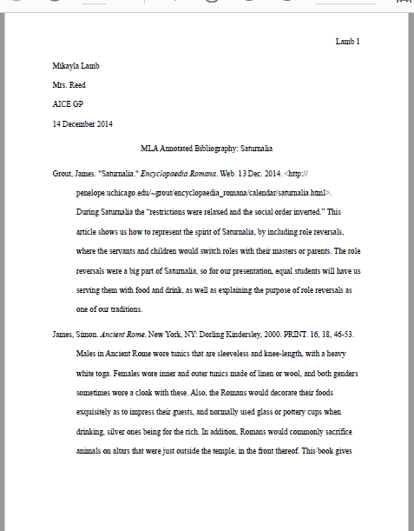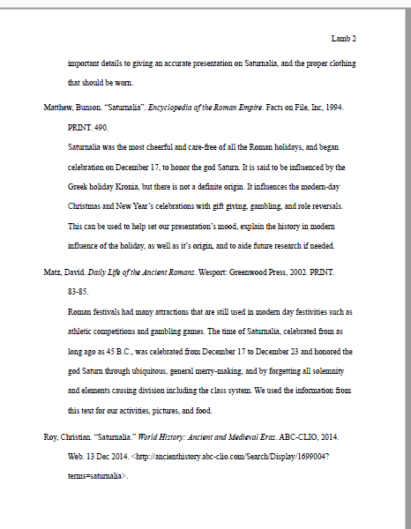
FINAL COPY SUBMITTED TO TURNITIN.COM NO LATER THAN THE MORNING OF THE PRSENTATION

The Visual-50 Pts (1 Presentation for the Group)
Sample but needs picts!!
Presentation Required: Minimum 5 Slide PPT
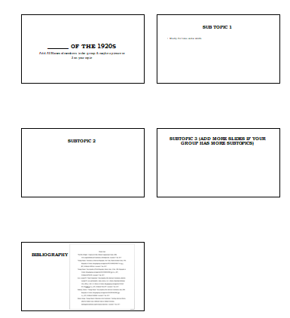
- Slide 1: Topic of the 1920s
- Last Slide: MLA Cited Sources used in the project (matched to the Annotated Bibliography)
- Slides should be more Visual than words (LOVE PICTURES!!)

Presentation to the Class
- Goal 3-5 minute Interesting & Engaging Group Presentation
- All Group members should speak during the presentation
- Don’t read from the slides
- May use notecards for reference
- HIGHLY ENCOURAGED to have additional elements to make the presentation engaging (costumes, music, foods that relate to your topics
FINAL COPY SUBMITTED TO TURNITIN.COM NO LATER THAN THE MORNING OF THE PRSENTATION
Suggested Timeline for the Project
Day 1: Divide Jobs/Research Materials/Topics/Start Research
Day 2: Share Research/Use Citationmachine.net/mla to cite sources/start Annotated Bibliography/Start PowerPoint
Day 3: Finalize Annotated Bibliography & PPT with group, practice presentation so everyone knows who goes when.
Day 4: Presentations!

