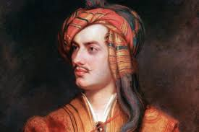
Peyton Bagby
Facts for the PPT
Lord Byron
- Born January 22, 1788
- Died April 19, 1824
- He was an English romantic poet writer
- Friend of Mary Shelly who wrote Frankenstein
He wrote:
- Don Juan (1819-1824)
- Beppo (1818)
- The Vision of Judgement (1822)
For the Annotated Bibliography
“Byron, Lord.” Grolier Encyclopedia of Knowledge. 1st Ed. 1991. Vol. 3.410. In the Encyclopedia we found out about Lord Byron, that he is a poet, he writes about romantic characters. He wrote stories like Don Juan (1819-1824), Beppo (1818), The Vision of Judgement (1822), and even knew Mary Shelly who wrote Frankenstein. We should use this for slide one of our power point because it tells us about Lord Byron and what he wrote.

