James M. Student
4831 Greenland Rd
ROUGH DRAFT
Jacksonville, FL 32258
904-260-3911
Objective
- Gain experience in a work environment
- Earn and save money to use in the future

Experience
Holy Spirit Catholic School- Volunteer/ 2017-2018
- Grounds cleanup
- Gate Duty for Basketball
- Concessions Duties for Basketball
- Helped coach the Basketball, Softball, and Soccer Teams

Holy Spirit Catholic School- Teams/ 08/2016 - 06/2018
- Basketball, Soccer, and Softball Teams

Soup Kitchen at Immaculate Conception Church- Volunteer/ 01/2018

Deutsche Bank sponsored Painting at Elementary School Annie Morgan- Volunteer/ 02/2018
- Helped repaint a school’s interior and exterior

Feeding Northeast Florida- Volunteer/ 03/2018
- Helped package boxes that contained non-perishable foods

Education
Holy Spirit Catholic School
Class of 2018

Awards and Acknowledgements
Multiple awards, medals, trophies, and MVPs from playing in Baseball, Basketball, Soccer, and Softball- 2013-2018
ROUGH DRAFT
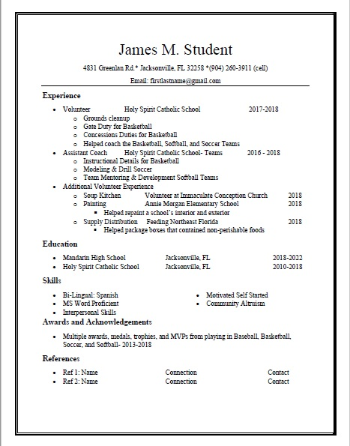
FINAL COPY

