George Michael: https://www.youtube.com/watch?v=1m6en0SQNFs
I feel so unsure
As I take your hand and lead you to the dance floor
As the music dies, something in your eyes
Calls to mind the silver screen
And all its sad good-byes
I'm never gonna dance again
Guilty feet have got no rhythm
Though it's easy to pretend
I know you're not a fool
Should've known better than to cheat a friend
And waste the chance that I'd been given
So I'm never gonna dance again
The way I danced with you
Time can never mend
The careless whispers of a good friend
To the heart and mind
Ignorance is kind
There's no comfort in the truth
Pain is all you'll find
I'm never gonna dance again
Guilty feet have got no rhythm
Though it's easy to pretend
I know you're not a fool
I should've known better than to cheat a friend
And waste the chance that I'd been…
What Instruments did you hear?

Speaker:
Occasion:
Audience:
Purpose:
Style:
TONE (Select from the Wheel)
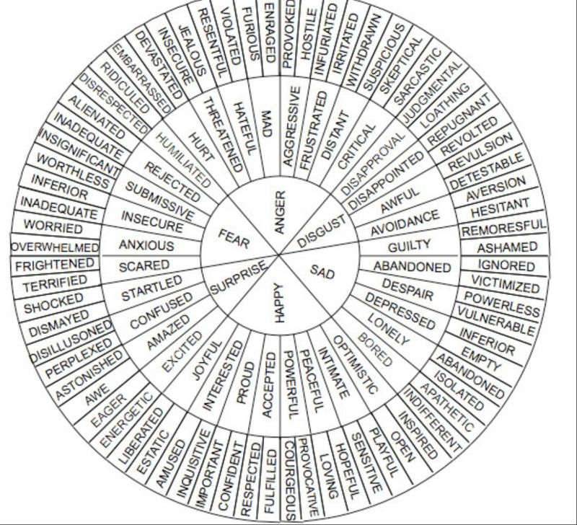

SEETHER:
https://www.youtube.com/watch?v=F2yL__ciZ9E
I feel so unsure
As I take your hand and lead you to the dance floor
As the music dies, something in your eyes
Calls to mind the silver screen
And all its sad good-byes
I'm never gonna dance again
Guilty feet have got no rhythm
Though it's easy to pretend
I know you're not a fool
Should've known better than to cheat a friend
And waste the chance that I'd been given
So I'm never gonna dance again
The way I danced with you
Time can never mend
The careless whispers of a good friend
To the heart and mind
Ignorance is kind
There's no comfort in the truth
Pain is all you'll find
I'm never gonna dance again
Guilty feet have got no rhythm
Though it's easy to pretend
I know you're not a fool
I should've known better than to cheat a friend
And waste the chance that I'd been…
What Instruments did you hear?

Speaker:
Occasion:
Audience:
Purpose:
Style:
TONE (Select from the Wheel)

