“I Hear America Singing”
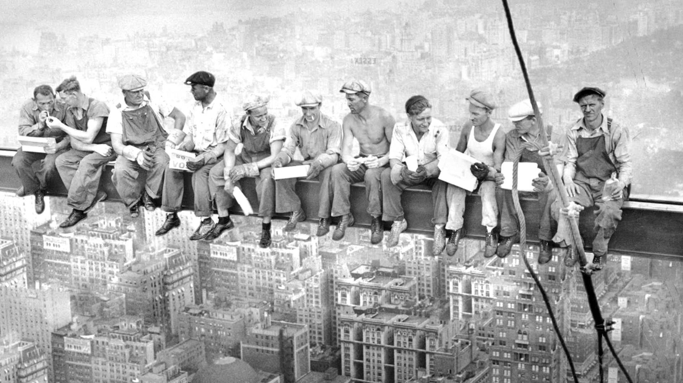
by
Walt Whiman

Jane Smith
Mrs. Reed
English 3 Honors-2nd
12 February 2021
Jane Smith
Mrs. Reed
English 3 Honors-2nd
12 February 2021
“I Hear America Singing”
Poem Original Text | Annotation
I hear America singing, the varied carols I hear, | Personification
Those of mechanics, each one singing his as it should be blithe and strong, | Catalog  Free Verse
The carpenter singing his as he measures his plank or beam, | Parallelism  Free Verse  Catalog
The mason singing his as he makes ready for work, or leaves off work, | Parallelism  Free Verse  Catalog
The boatman singing what belongs to him in his boat, the deckhand singing on the steamboat deck, | Parallelism  Catalog  Free Verse
The shoemaker singing as he sits on his bench, the hatter singing as he stands, | Parallelism  Catalog  Free Verse
The wood-cutter’s song, the plowboy’s on his way in the morning, or at noon intermission or at sundown, | Catalog  Free Verse
The delicious singing of the mother, or of the young wife at work, or of the girl sewing or washing, | Catalog  Free Verse
Each singing what belongs to him or her and to none else, | Free Verse
The day what belongs to the day—at night the party of young fellows, robust, friendly, | Apostrophe  Free Verse
Singing with open mouths their strong melodious songs. | Free Verse
SOAPSTone Analysis: “I Hear America Singing”
S=The Immigrant, proud to be in this country
O=Their arrival to the US or a Letter back home to family
A=The Working Class of American or immigrants who haven’t arrive to the U.S. yet
P=To have them see the Hope & the Potential to achieve the American Dream
S=the Unity of the Working Class in America
Tone=Proud
#workingtogether
The theme of this piece would be working together, as all of the different laborers are “singing” together throughout the piece. Whitman’s catalog of these varying jobs, yet structuring them side by side shows their diversity and at the same time toiling together towards a better future.
“Lunch Atop a Skyscraper” by Charles C. Ebbets
I selected “Lunch Atop a Skyscraper” by Charles C. Ebbets as it showed the “Lunch Atop a Skyscraper” by Charles C. Ebbets “the party of young fellows, robust, friendly,” (Ln 10) embodying the durability and strife of the working man. This shows “the mechanics…the carpenter….the mason”(Ln. 2-4) not only as they were toiling at their jobs, but that they could all come together. I feel like this image, capture at the top of the Rockefeller Center Building under construction gives the same feeling of the “America Singing” (Ln 1) in Whitman’s poem, the music of the machinery as not only the building is being built, but the country as well.

Annotated Bibliography
Bauer, Aaron. “Literary Devices: Exploring Anaphora Through the Poetry of Walt Whitman.” Writersdigest.com, The Writer's Digest Magazine, 31 May 2018, www.writersdigest.com/write-better-poetry/literary-devices-exploring-anaphora-poems-walt-whitman. On this source I found information about Whitman's use of Anaphora in "I Hear American Singing" as well as his use of Free Verse. I plan on using this to help explain the significance of the Anaphora's in Whitman's poem as well as to make connections to Langston Hughes "I, Too."
Gambino, Megan. “Lunch Atop a Skyscraper Photograph: The Story Behind the Famous Shot.” Smithsonianmag.com, The Smithsonian Magazine, 19 Sept. 2012, www.smithsonianmag.com/history/lunch-atop-a-skyscraper-photograph-the-story-behind-the-famous-shot-43931148/. On this source I found not only the picture for the cover of the packet of the "Lunch Atop a Skyscraper" but I also found details about the fact that this photo was a propaganda piece for the building of Rockefeller Center. I am using this information to compare it to the "Young fellows" (Ln 10) in the poem.
Whitman, Walt. “I Hear America Singing.” Poetryfoundation.org, The Poetry Foundation, 2021, www.poetryfoundation.org/poems/46480/i-hear-america-singing. I found my copy of "I hear America Singing" by Walt Whitman on this source, it also linked to other poems by Whitman for Referencing his body of work.

