Walden by Henry David Thoreau  The Text | My Thoughts
Read
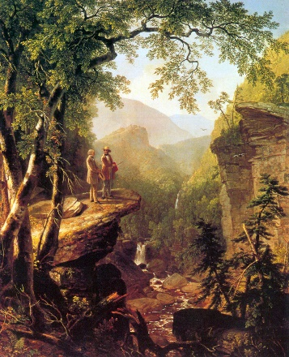
(1)I went to the woods because I wished to live deliberately, to front only the essential facts of life, and see if I could not learn what it had to teach, and not, when I came to die, discover that I had not lived. I did not wish to live what was not life, living is so dear; nor did I wish to practise resignation, unless it was quite necessary. I wanted to live deep and suck out all the marrow of life, to live so sturdily and Spartan-like as to put to rout all that was not life, to cut a broad swath and shave close, to drive life into a corner, and reduce it to its lowest terms, and, if it proved to be mean, why then to get the whole and genuine meanness of it, and publish its meanness to the world; or if it were sublime, to know it by experience, and be able to give a true account of it in my next excursion. For most men, it appears to me, are in a strange uncertainty about it, whether it is of the devil or of God, and have somewhat hastily concluded that it is the chief end of man here to "glorify God and enjoy him forever."

(2) Still we live meanly, like ants; though the fable tells us that we were long ago changed into men; like pygmies we fight with cranes; it is error upon error, and clout upon clout, and our best virtue has for its occasion a superfluous and evitable wretchedness. Our life is frittered away by detail. An honest man has hardly need to count more than his ten fingers, or in extreme cases he may add his ten toes, and lump the rest. Simplicity, simplicity, simplicity! I say, let your affairs be as two or three, and not a hundred or a thousand; instead of a million count half a dozen, and keep your accounts on your thumb-nail. In the midst of this chopping sea of civilized life, such are the clouds and storms and quicksands and thousand-and-one items to be allowed for, that a man has to live, if he would not founder and go to the bottom and not make his port at all, by dead reckoning, and he must be a great calculator indeed who succeeds. Simplify, simplify. Instead of three meals a day, if it be necessary eat but one; instead of a hundred dishes, five; and reduce other things in proportion. Our life is like a German Confederacy, made up of petty states, with its boundary forever fluctuating, so that even a German cannot tell you how it is bounded at any moment. The nation itself, with all its so-called internal improvements, which, by the way are all external and superficial, is just such an unwieldy and overgrown establishment, cluttered with furniture and tripped up by its own traps, ruined by luxury and heedless expense, by want of calculation and a worthy aim, as the million households in the land; and the only cure for it, as for them, is in a rigid economy, a stern and more than Spartan simplicity of life and elevation of purpose. It lives too fast. Men think that it is essential that the Nation have commerce, and export ice, and talk through a telegraph, and ride thirty miles an hour, without a doubt, whether they do or not; but whether we should live like baboons or like men, is a little uncertain. If we do not get out sleepers, and forge rails, and devote days and nights to the work, but go to tinkering upon our lives to improve them, who will build railroads? And if railroads are not built, how shall we get to heaven in season? But if we stay at home and mind our business, who will want railroads? We do not ride on the railroad; it rides upon us. Did you ever think what those sleepers are that underlie the railroad? Each one is a man, an Irishman, or a Yankee man. The rails are laid on them, and they are covered with sand, and the cars run smoothly over them. They are sound sleepers, I assure you. And every few years a new lot is laid down and run over; so that, if some have the pleasure of riding on a rail, others have the misfortune to be ridden upon. And when they run over a man that is walking in his sleep, a supernumerary sleeper in the wrong position, and wake him up, they suddenly stop the cars, and make a hue and cry about it, as if this were an exception. I am glad to know that it takes a gang of men for every five miles to keep the sleepers down and level in their beds as it is, for this is a sign that they may sometime get up again.

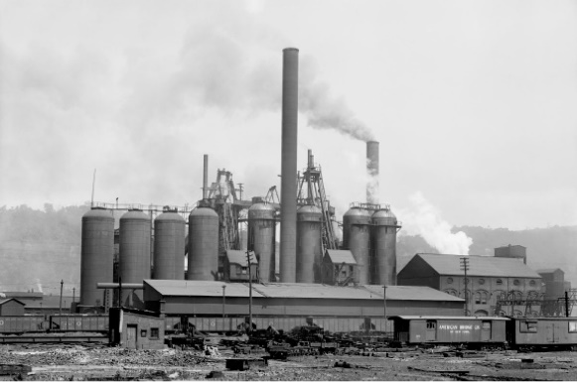
(3) Why should we live with such hurry and waste of life? We are determined to be starved before we are hungry. Men say that a stitch in time saves nine, and so they take a thousand stitches today to save nine tomorrow. As for work, we haven't any of any consequence. We have the Saint Vitus' dance, and cannot possibly keep our heads still. If I should only give a few pulls at the parish bell-rope, as for a fire, that is, without setting the bell, there is hardly a man on his farm in the outskirts of Concord, notwithstanding that press of engagements which was his excuse so many times this morning, nor a boy, nor a woman, I might almost say, but would forsake all and follow that sound, not mainly to save property from the flames, but, if we will confess the truth, much more to see it burn, since burn it must, and we, be it known, did not set it on fire—or to see it put out, and have a hand in it, if that is done as handsomely; yes, even if it were the parish church itself. Hardly a man takes a half-hour's nap after dinner, but when he wakes he holds up his head and asks, "What's the news?" as if the rest of mankind had stood his sentinels. Some give directions to be waked every half-hour, doubtless for no other purpose; and then, to pay for it, they tell what they have dreamed. After a night's sleep the news is as indispensable as the breakfast. "Pray tell me anything new that has happened to a man anywhere on this globe"—and he reads it over his coffee and rolls, that a man has had his eyes gouged out this morning on the Wachito River; never dreaming the while that he lives in the dark unfathomed mammoth cave of this world, and has but the rudiment of an eye himsel
Text Questions (Give Evidence from the Text)
Why did Thoreau decide to live in the woods? (See paragraph 1)

What is the comparison Thoreau makes between our lives and a German confederacy? (See paragraph 2:

