Negative Events | Year/Title |  | Positive Events
Colonial North America's slave trade begins when the first American slave carrier, Desire, is built and launched in Massachusetts. | 1636  Slave trade begins:
 | 1776 DECLARATION OF INDEPENDENCE |  | In Philadelphia, Pennsylvania, members of the Continental Congress sign the Declaration of Independence which stated:  We hold these Truths to be self-evident, that all Men are created equal, that they are endowed by their Creator with certain unalienable Rights, that among these are Life, Liberty, and the Pursuit of Happiness.
but smuggling continues | 1808  Slave trade banned: |  | The US outlaws importing African slaves.
The United States Supreme Court decides, seven to two, that blacks can not be citizens and that Congress has no authority to outlaw slavery in any territory. | 1857  Dred Scott case:
Northern and Southern states, divided over slavery, battle for four years in a war that claims 620,000 lives. | 1861-1865  Civil War
 | 1863- Emancipation proclamation |  | President Abraham Lincoln decrees that all slaves are free on January 1, 1863.
 | 1865 13th Amendment |  | The 13th Amendment to the United States Constitution outlaws slavery
Jim Crow Laws enforced racial segregation at the state and local level in Southern American states. For example, a Virginia law made it illegal for black and white children to attend the same schools. | 1870  Jim Crow laws begin
Southern states adopt new constitutions and voting laws designed to discourage black voters from casting their votes. Examples include poll taxes, threat of physical violence, and literacy tests. | 1890  voting restrictions
The United States Supreme Court established the "Separate but Equal Doctrine," stating that legal racial segregation does not violate the equal protection clause of the 14th Amendment. | 1896  Plessy v. Ferguson
Negative Events | Year/Title | Positive Events
The KKK sought to maintain white supremacy with the use of violence as an intimidation force. More than 4,000 black Americans were lynched in the time between the end of the Civil War and the 1960s. | 1900-1960s Rise of the Ku Klux Klan:
The United States Supreme Court ruled unanimously that "separate educational facilities are inherently unequal" and that "the plaintiffs and others similarly situated… are … deprived of the equal protection of the laws guaranteed by the Fourteenth Amendment." The decision outlawed segregation in all public schools in the United States. | 1954 Brown v. Board of Education
Murder of Emmett Till: Emmett Till, a fourteen year-old black boy, was brutally murdered for allegedly whistling at a white woman in Mississippi. Two white men charged with the crime were acquitted by an all-white jury. They later boasted about committing the murder. The public outrage generated by the case helped spark the Civil Rights Movement. | 1955 |  | Rosa Parks takes a stand: Rosa Parks was arrested in Montgomery, Alabama, for violating a Jim Crow ordinance by refusing to give up her bus seat for a white man. Her arrest led to a successful citywide bus boycott, which brought Martin Luther King, Jr. to national prominence.
 | 1957 Little Rock Nine |  | President Dwight D. Eisenhower ordered federal troops into Little Rock, Arkansas, after unsuccessfully trying to persuade Arkansas Governor Orval Faubus to give up his efforts to block desegregation at Central High. Faubus and a mob of whites were forced to allow nine African American children to attend school.
 | 1961 Freedom Riders |  | The Congress of Racial Equality (CORE) sent student volunteers on bus trips in the South to test new laws prohibiting segregation in interstate travel. One of the first groups of "freedom riders" encountered its first problem two weeks later, when a mob in Alabama set the riders' bus on fire. The program continued, and by the end of the summer 1,000 volunteers-blacks and whites-had participated.
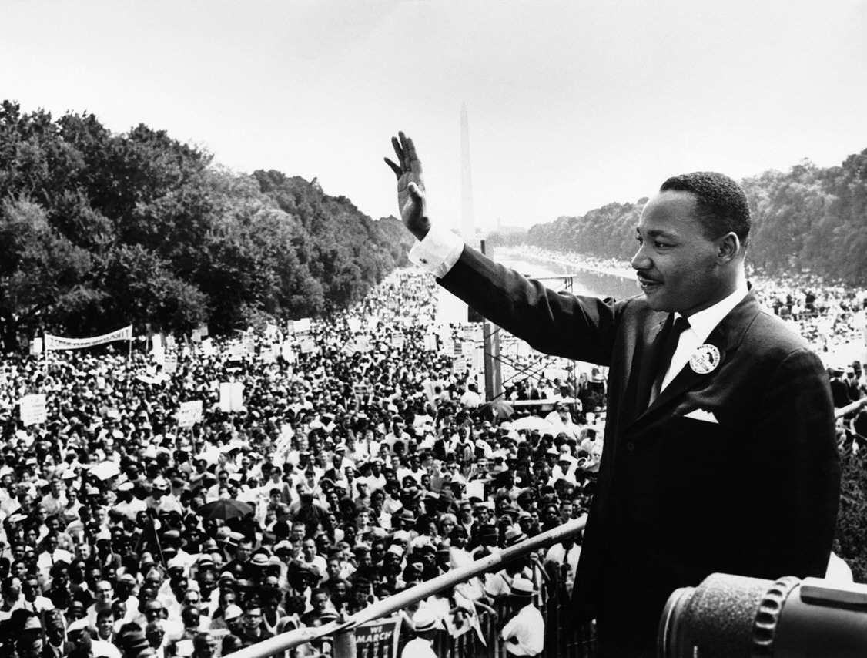 | 1963 |  | March on Washington for jobs & Freedom: The civil rights movement reached its peak when 250,000 blacks and whites gathered at the Lincoln Memorial for the March on Washington for Jobs and Freedom, which included the demand for passage of meaningful civil rights laws. Martin Luther King, Jr. delivered his famous I Have a Dream speech.

