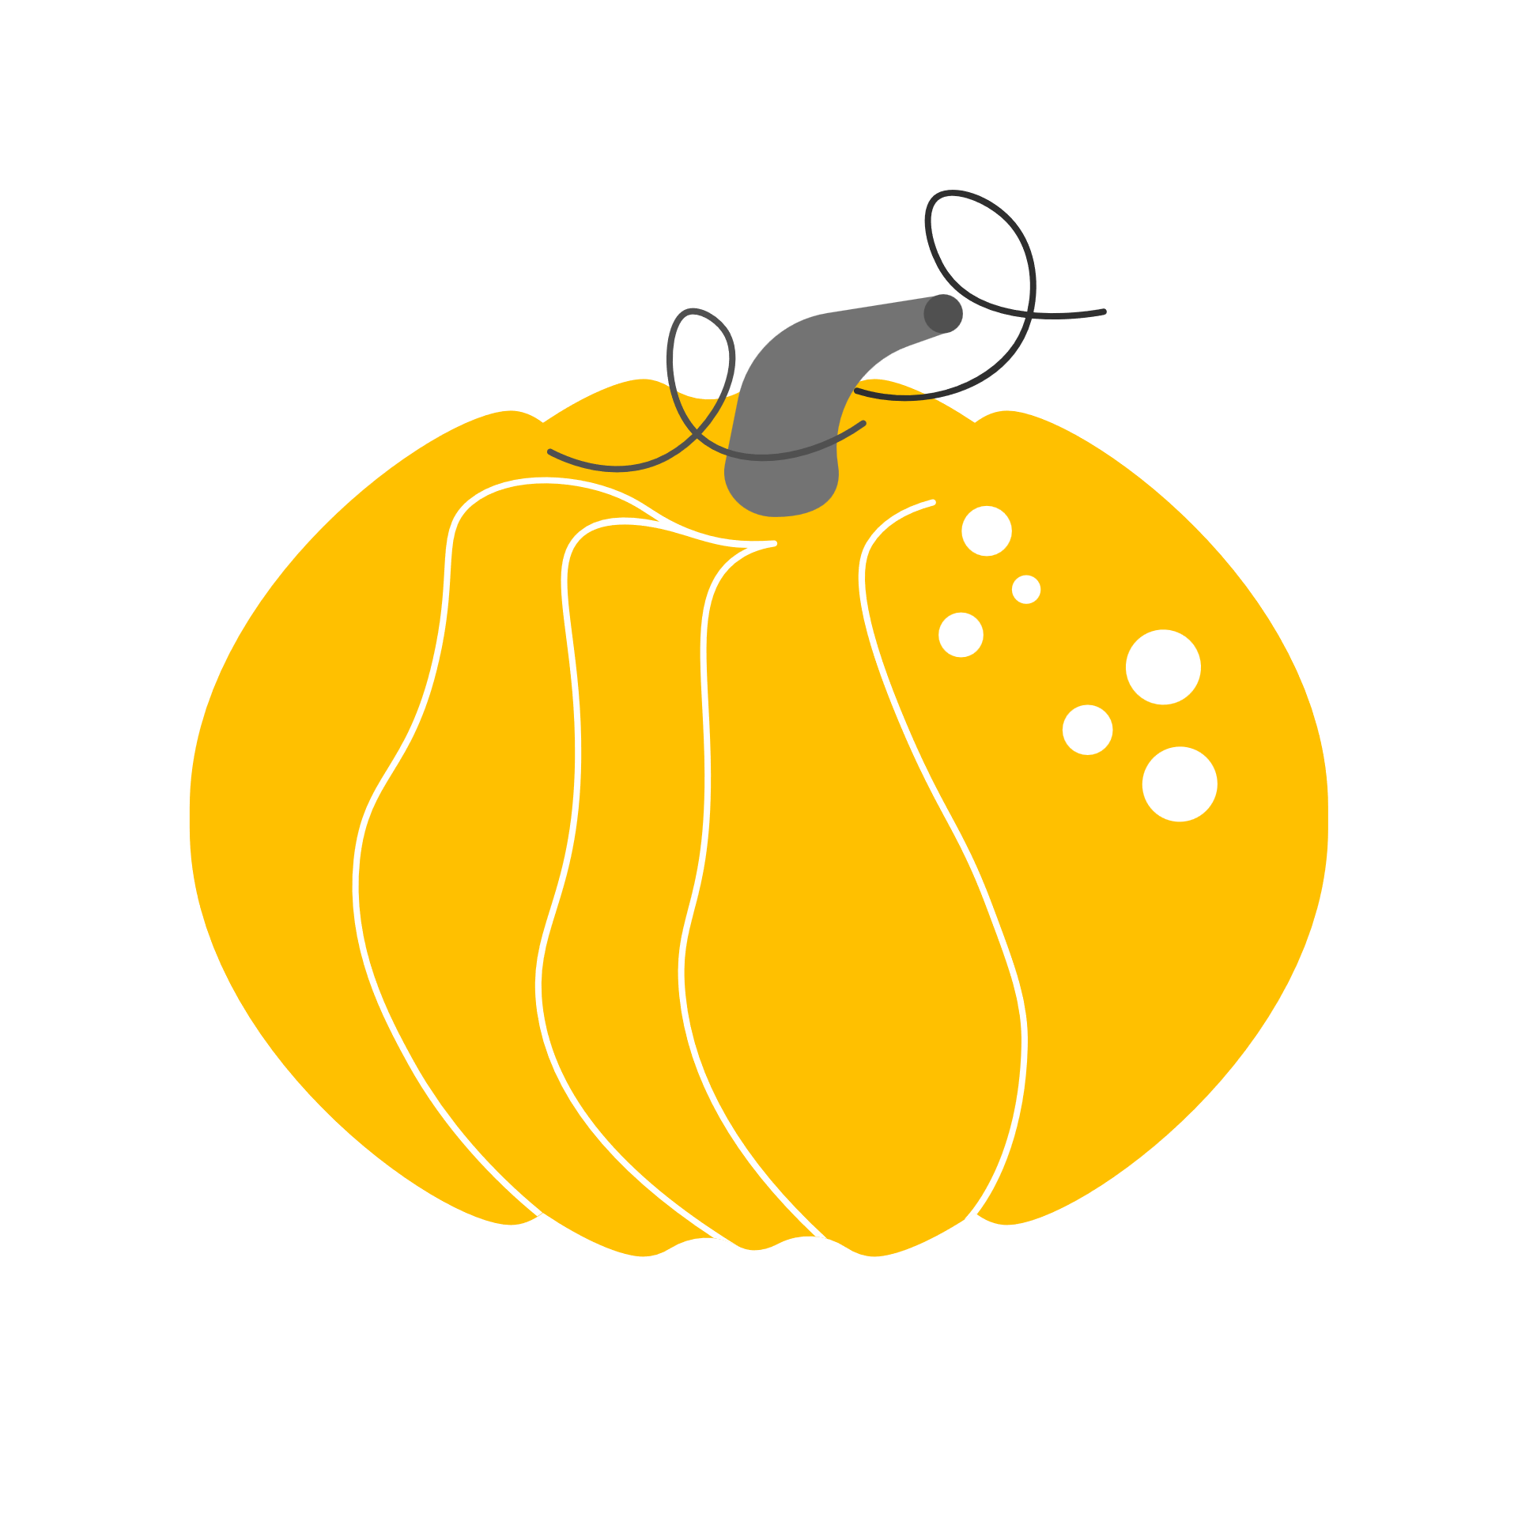October: leading into the New Quarter we break into new ideas and continue established practices.
- Established Practices
  - CNN Student News
    - Detailed Notes
      - Who, What, When, Where, Why
    - Bi-Weekly Quizzes
      - Check in On Headlines to see Current Events
      - Peer Review
  - Weekly Columns
    - Headline
    - Sub-Header
    - By-Line
    - 250 Minimum Column Including
      - Quotes from a Minimum of 2 sources
    - Picture Integrated in Article with Caption
    - MLA CITED Sources
    - Writer Mini-Bio
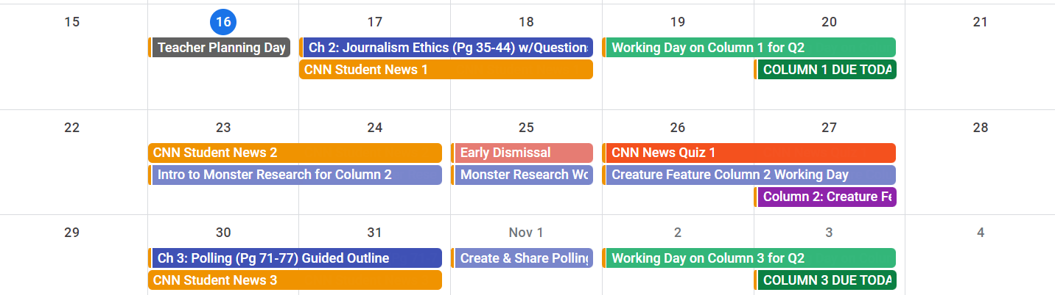
Week | Date | Agenda | Notes | Homework | Done
Week 1 | 10/17-18 | CNN Student News 1  Ch 2: Journalism Ethics (Pg. 35-44) w/Questions |  | Plan Column 1 Q2
Week 1 | 10/19-20 | Working Time on Column 1 (DUE to Focus 10/20) |  | Finish Column 1
Week 2 | 10/23-24 | CNN Student News 2  Intro into Monster Research for Column 2 |  | Plan Column 2 Q2
Week 2 | 10/25 | Working Day Column 2 |  | Finish Column 2
Week 2 | 10/26-27 | QUIZ CNN Student News 1 & 2  Working Time on Column 2 (DUE to Focus 10/27)
Week 3 | 10/30-31 | CNN Student News 3  Ch 3: Polling (Pg. 71-77) w/Guided Outline |  | Plan Column 3 Q2
Week 3 | 11/1 | Create & Share Polling Form & QR for Posting |  | Finish Column 3
Week 3 | 11/2-3 | Working Time on Column 3 (DUE to Focus 11/3)

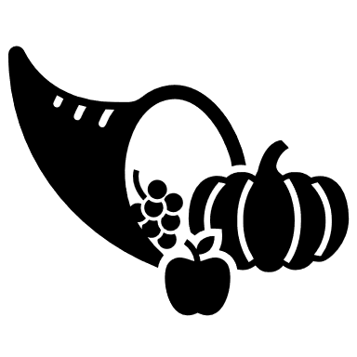November: building towards greater projects, more elements of Journalism, but still continuing routines.
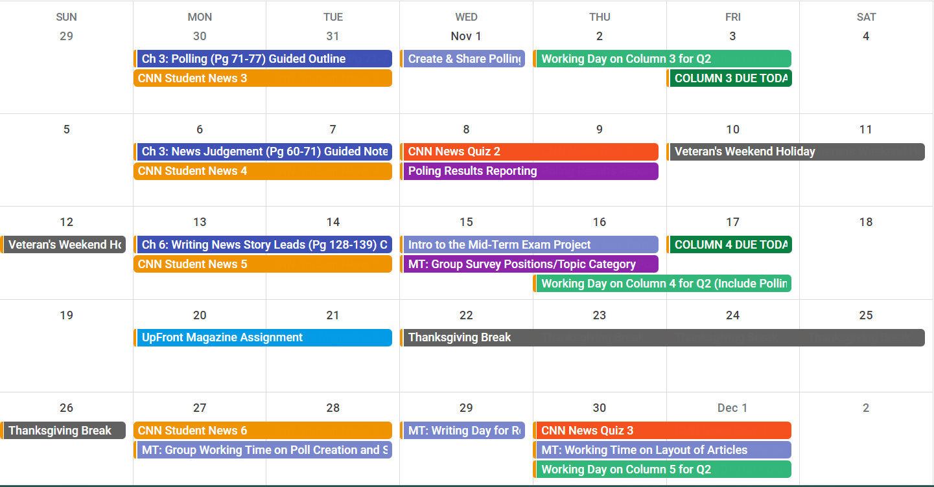
Week | Date | Agenda | Notes | Homework | Done
Week 4 | 11/6-7 | CNN Student News 4  Ch 3: News Judgement (Pg. 60-71) Guided Notes
Week 4 | 11/8-9 | QUIZ CNN Student News 3 & 4  Polling Results Report (DUE to Focus 11/9)
Veteran’s Holiday Weekend 11/10-11/12
Week 5 | 11/13-14 | CNN Student News 5  Ch 6: Writing News Story Leads (Pg. 128-139) Cornell Notes |  | Plan Column 4 Q2
Week 5 | 11/15-16 | Intro to Mid-Term Exam Project (Mini-Magazine)  - Complete Form for Team Positions & Topics  Working Time on Column 4 (Including Polling Results Reflection) |  | Finish Column 4
Week 5 | 11/17 | Working Time on Column 4 (DUE to Focus 11/17)
Week 6 | 11/20-21 | UPFRONT MAGAZINE Review Assignment
Thanksgiving Break 11/22-11/26
Week 7 | 11/27-11/28 | CNN Student News 6  MT: Group Working Time on Poll Creation & Staff Articles |  | Plan Column 5 Q2
Week 7 | 11/29 | MT: Writing Day for Rough Drafts
Week 7 | 11/13-12/1 | QUIZ CNN Student News 5 & 6  MT: Group Working Time on Article Layout  Working Time on Column 5 |  | Finish Column 5
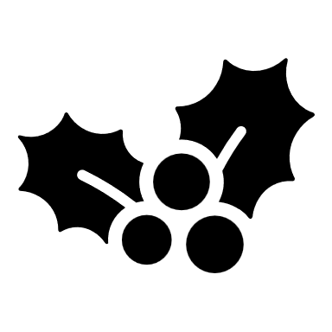December: Demonstration of Journalism elements, culmination of activities for Semester 1.
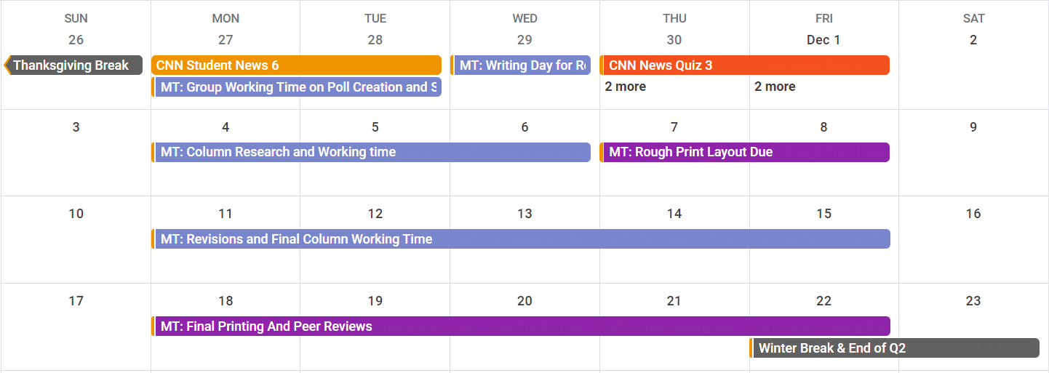
Week | Date | Agenda | Notes | Homework | Done
Week 8 | 12/4-6 | MT: Column Research & Working Days (Mon-Wed)
Week 8 | 12/7-8 | MT: Rough Print Layout Due for Review with Publisher!!!
Week 9 | 12/11-15 | MT: Final Revisions & Final Column Working Time!
Week 10 | 12/18-21 | FINAL MID TERM MAGAZINE PUBLISHED AND PEER REVIEW WEEK!!
Winter Break & END OF Q2!! 12/22/23-1/1/24

Mid-Term Mini Magazine Preview
  - Group Staff Positions (All Group Members will be Journalists as well)
    - Editor
    - Co-Editor
    - Graphics Director
    - Fact Checker(s)
    - Print Review
  - Articles Included (Each Group Member will work on 1-2 Articles)

    - Science/Technology
    - Politics/Government
    - Environment
    - Social
    - Media
    - Poll
    - Cartoon (Found or Created)
    - Sports
    - Advice Column

