Morgan State Shooting Leads to 5 Injured and No Suspects
The gunmen of this homecoming attack are still unknown, and the victims are harrowed.
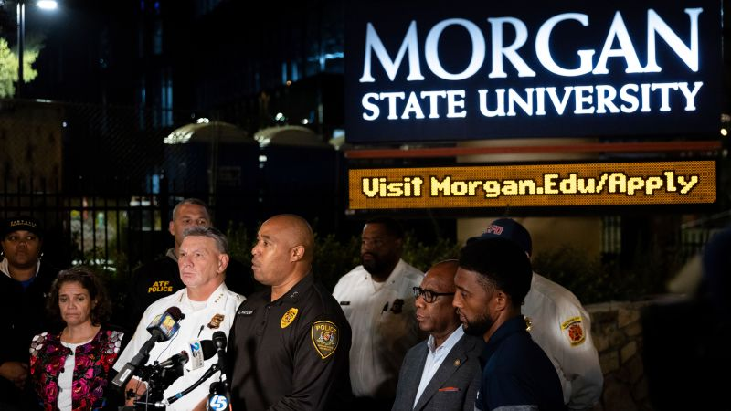
By ZARA GAJIC on OCTOBER 10, 2023
Morgan State University, a popular university in Baltimore, Maryland, has recently been struck with tragedy as 5 persons were injured in a shooting on campus. The attack occurred on the evening of Tuesday, October 3, 2023.
The attack where 4 students and another bystander were injured occurred during the University’s popular homecoming night. Students were outside the school, leaving the coronation crowning, when “two gunshots hit the front window and everyone just started running,” as told by a student known as David, who lives at the University. The Baltimore Police Department arrived quickly, and SWAT did a sweep of all floors on campus twice, yet found no suspects and deduced that this was no longer an active shooter situation.
The Baltimore Police Department believes that this onslaught was the result of a dispute between two separate groups with the gunmen harboring the same target, the number of weapons being deduced by the ballistics. Baltimore Police commissioner Richard Worley stated that “[they] believe the five victims who were struck were unintended targets.”
Following the attack, on Wednesday evening, the police department released a video of four individuals from the night prior who were shown near the scene of the attack. Police asked for help in identifying who these individuals were yet provided no clues or context as to why.
For the first time in the school’s history, all upcoming homecoming events have been postponed until the shooters have been identified: to protect the remaining peace of the students, staff, and families involved.
As for the time being, the shooters have not been identified and there are no suspects, with only the people of interest in the released video being any kind of progress. The injured students, however, have fully recovered.
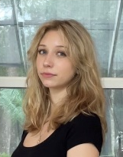
─── ⋆⋅☆⋅⋆ ───── ⋆⋅☆⋅⋆ ───── ⋆⋅☆⋅⋆ ───── ⋆⋅☆⋅⋆ ───── ⋆⋅☆⋅⋆ ───── ⋆⋅☆⋅⋆ ───── Zara Gajic is a high school student dedicated to her studies and (more often) her friends. She loves to keep up with all things trending and is frequently watching and listening to new media. Most of all, especially depicted in her writing, she loves music. ─── ⋆⋅☆⋅⋆ ───── ⋆⋅☆⋅⋆ ───── ⋆⋅☆⋅⋆ ───── ⋆⋅☆⋅⋆ ───── ⋆⋅☆⋅⋆ ───── ⋆⋅☆⋅⋆ ─────

Works Cited
- https://abcnews.go.com/US/morgan-state-university-baltimore-shooting-persons-of-interest/story?id=103744943
- https://www.usatoday.com/story/news/nation/2023/10/07/morgan-state-shooting-prompts-university-to-historically-cancel-homecoming/71090550007/
- https://www.cnn.com/2023/10/03/us/baltimore-morgan-state-university-campus-shooting/index.html
- https://www.espn.com/college-football/story/_/id/38573065/morgan-state-cancels-homecoming-game-campus-shooting

