Directions: In preparation for your Mid-Term Exam Project you will be dissecting the elements of 2 New York Times UpFront Magazines to Identify the parts that will be expected in your Finished Publication.
Cover Items | February 21, 2022 Issue | April 25, 2022 Issue
Front Cover Items | 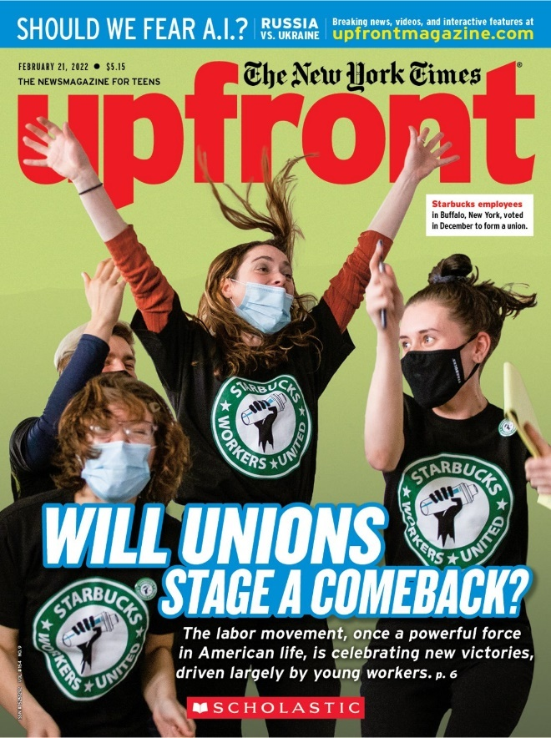 | 
What is the TITLE of the Issue? (Not the Magazine)

What is the SUBTITLE?

How do they Caption the Photo?

What do you notice about the Picture? (Active? Passive? What’s Included?

What is in the Banner at the Top?
List 2 OTHER things they List on the Front of the Magazine

INSIDE THE ISSUE | February 21, 2022 Issue | April 25, 2022 Issue
What items are on the INSIDE Left Page?

What is “The Big Picture?

What is the Title & Finger on the HAND of this Article?
Approx How Long is this Article?
Does it cover the 5Ws & How?
News & Trends Pgs 4 & 5
How many SHORT Articles are covered on these pages?
How Many & # Categories do they cover?
Pg 4 Top:
Title
Pg 4 Middle:
Title
Pg 5 Top Left:
Title
Pg 5 Top Right:
Title
Pg 5 Bottom:
Title
What was the “Numbers in the News”?
The Feature Articles
What LONG Article is Featured Next
How many Sub-Sections (look @ subtitles) /Pages is it?
What is the Next LONG Article?
How many Sub-Sections (look @ subtitles) /Pages is it?
What is included in this 2nd Long Article? (What other Features?)

The Debate
The Question

The Writer Of the YES Side
The Writer of the NO Side
How do they SUPPORT their Side?

Does EITHER SIDE Show Bias?

The Back Cover
What is on the Back Covers?

How Many?

What do some of them relate to?
Final Reflection | My thoughts on these Magazines/What they Include for a Student to Read | What Questions do I have on the Mid Term Project?

