Harry Potter
#4 Privet Drive, Cupboard Under the Stairs, Little Whinging, Surrey, England | 904-555-000| snitchcatcher01@gmail.com
April 8th
Mrs. Reed
11th Grade ELA Instructor
Mandarin High School
4831 Greenland Rd
Jacksonville, FL 32258
Dear Mrs. Reed:
2-3 Sentences that discuss what your Post High School Plans are based on the materials you have collected in this packet.
3-5 Sentences as to what you have learned through this process, what were you surprised by, what do you now know about that you did not before? BE SPECIFIC (Reference for example the speakers or how you learned to create a resume/cover letter/professional e-mail, or what you learned about your)
2-3 Sentences as to if you feel you now embody those character traits that I was looking for at the start of the semester and how this process has been beneficial to you, how has this packet prepared you to move on beyond high school?
1-2 as to why what we learned over this semester is important and what more I could include for next year (other Presenters, Topics, Etc.)
Sincerely,
Harry Potter

Be sure to include:
- Name (Biggest Font)
- Address
- Phone Number for Contact (specify type, home or cell)
- Email Address

- Employment/Experience-This is actual Paid work or Volunteering
  - Have Position, Company, Dates (Years)
  - 2-3 Bullets of Responsibilities
  - EX:
    - Childcare Facilitator*Various Clients* Dates
      - Nutritional planning & preparation\
      - Activities scheduler & monitoring
      - Child wellbeing & safety
    - Lawn Maintenance Specialist*Various Clients*dates
      - Mowing of grass to client specifications
      - Edging & trimming of landscaping
      - Maintaining all equipment required
- Education-Minimum 2 Schools, most recent 1st
  - Name, location, Dates attended
  - Add Programs of Study (Honors/AICE)
  - Academic Awards (GPA, Etc)
- Skills (MS Word Proficient, PowerPoint, etc., any special training for jobs-CPR/First Aid)
  - Bullet Points Recommended
  - 5 points approx, over that, 2 columns
- Extra Curricular (Sports, Clubs, Awards, etc)
  - Years completing it (have you done something like ballet for 8 years? Include that here)
  - NJHS, Interact, etc
  - Positions held, officer, team captain, etc
- Interesting facts (in a list, fluent in Spanish, 1260 SAT Score, etc.)
- References Min 2, non family, with company/connection, Phone # & E-mail

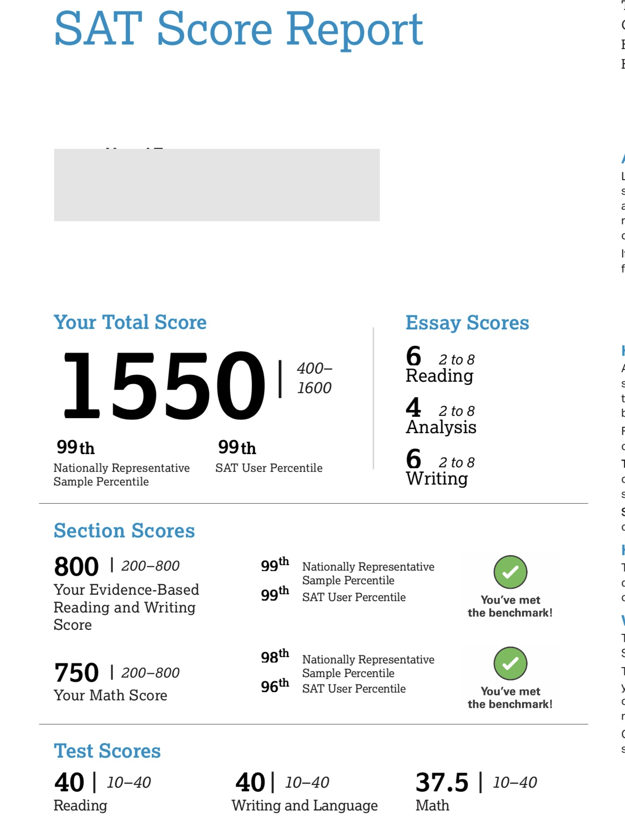

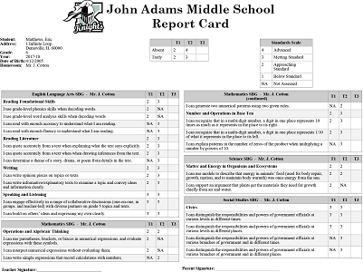

John Doe
Mrs. Reed
English 3 -2A
10 May 2012
Discuss an Impactful Day in Your Life
When I was assigned to duty at Patrick Air Force Base part of my duties were to work with NASA during Shuttle and satellite launches. I coordinated the operation of radar and telemetry (data) sites around the world as a Range Control Officer (RCO). For Shuttle launches I could also be assigned as the Air Force Rescue coordinator in case there was a problem with the Orbiter during launch or landing.
As the newest RCO, I was assigned to work with a certified RCO on NASA Mission 51L (Orbiter-Challenger). The Mission was originally scheduled as an afternoon launch on January 22 however due to weather problems and other delays, the mission did not launch until the morning of January 28. As an RCO I was required to conduct equipment tests and system verifications prior to and during the launch countdown. With the delays, I was required to conduct a telemetry (Data) test the night before which did not end until 9:00 pm. Following this test, I went to see the orbiter Columbia taken off the big 747 transport airplane. While watching, astronauts Ellison Onizuka & Christa McAuliffe came by to also watch. I spent about 2 hours talking with them before all of us had to leave to get some sleep before the launch.
For a Shuttle launch the countdown begins for the launch crew 8 – 12 hours prior to the initially scheduled launch time. For me this meant driving to the Cape in the dark at 4:00 am. Along the road, signs at places like McDonalds and Wendy’s said “GO, CHALLENGER” or “BEST WISHES CHRISTA”. The community surrounding the Cape REALLY supported NASA and the Shuttle program.
The weather that morning was unusually cold, with temperatures close to 31 °F, the minimum temperature permitted for launch. This cold resulted in several delays in the launch count to let the resulting ice melt. The launch took place at the last possible minute for that day. My position was in a windowless building but with access to cameras all over the Cape. I had been watching one of the long range cameras and had to switch to a data screen. When I came back to the camera was when the explosion occurred. I stared at the bottom of the main explosion cloud waiting to see the Orbiter pop out headed back to the Cape. Even as I watched, I knew the astronauts had died.
With this tragedy, my second job as Rescue Coordinator came into play with units from NASA, Air Force, Navy and Coast Guard. I coordinated the aircraft and ship searches for the remainder of that day and for 12-hours a day for the next two weeks. At that time, the search operations were in the Gulf Stream near your home in Jacksonville. My responsibilities were transferred to a Coast Guard person in Savannah.

John Doe
Mrs. Reed
English 3 -2A
10 May 2012
Discuss an Impactful Day in Your Life
When I was assigned to duty at Patrick Air Force Base part of my duties were to work with NASA during Shuttle and satellite launches. I coordinated the operation of radar and telemetry (data) sites around the world as a Range Control Officer (RCO). For Shuttle launches I could also be assigned as the Air Force Rescue coordinator in case there was a problem with the Orbiter during launch or landing.
As the newest RCO, I was assigned to work with a certified RCO on NASA Mission 51L (Orbiter-Challenger). The Mission was originally scheduled as an afternoon launch on January 22 however due to weather problems and other delays, the mission did not launch until the morning of January 28. As an RCO I was required to conduct equipment tests and system verifications prior to and during the launch countdown. With the delays, I was required to conduct a telemetry (Data) test the night before which did not end until 9:00 pm. Following this test, I went to see the orbiter Columbia taken off the big 747 transport airplane. While watching, astronauts Ellison Onizuka & Christa McAuliffe came by to also watch. I spent about 2 hours talking with them before all of us had to leave to get some sleep before the launch.
For a Shuttle launch the countdown begins for the launch crew 8 – 12 hours prior to the initially scheduled launch time. For me this meant driving to the Cape in the dark at 4:00 am. Along the road, signs at places like McDonalds and Wendy’s said “GO, CHALLENGER” or “BEST WISHES CHRISTA”. The community surrounding the Cape REALLY supported NASA and the Shuttle program.
The weather that morning was unusually cold, with temperatures close to 31 °F, the minimum temperature permitted for launch. This cold resulted in several delays in the launch count to let the resulting ice melt. The launch took place at the last possible minute for that day. My position was in a windowless building but with access to cameras all over the Cape. I had been watching one of the long range cameras and had to switch to a data screen. When I came back to the camera was when the explosion occurred. I stared at the bottom of the main explosion cloud waiting to see the Orbiter pop out headed back to the Cape. Even as I watched, I knew the astronauts had died.
With this tragedy, my second job as Rescue Coordinator came into play with units from NASA, Air Force, Navy and Coast Guard. I coordinated the aircraft and ship searches for the remainder of that day and for 12-hours a day for the next two weeks. At that time, the search operations were in the Gulf Stream near your home in Jacksonville. My responsibilities were transferred to a Coast Guard person in Savannah.

