H.P. Lovecraft: The Father of Cosmic Horror’s Dark Legacy
  - A deeper look into H.P. Lovecraft’s life, influence, works, and the inspirations woven into them
by Anne Chaves on October 30, 2023

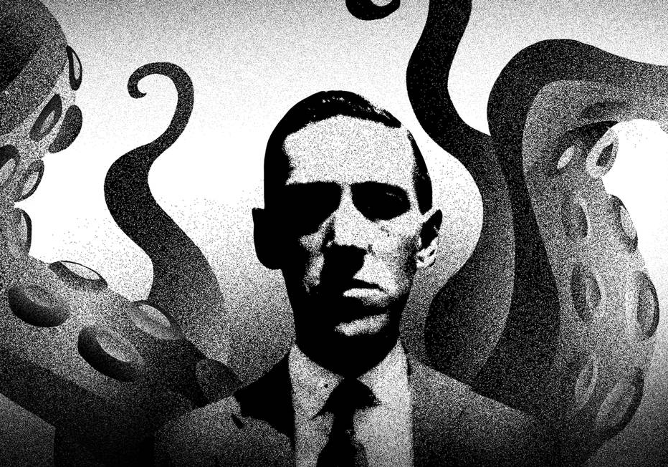
Illustration by André Mello

Known as many things, such as being the “20th century master of the Gothic tale of terror,” the “King of Weird”, and the “Father of Cosmic Horror,” H.P. Lovecraft is an influential figure in modern horror and literary fiction today. With works that dabbled uniquely with the bizarre and the unknown, he would mark the creation of new subgenres in horror and establish some of the most iconic creatures in horror fiction.
Born in 1890, H.P Lovecraft (his full name being Howard Phillips Lovecraft) grew up in Providence as the only son to an initially wealthy family. Ever since his early years of life he was shrouded by the air of death, as his father was committed to Butler Hospital after having a mental breakdown and being diagnosed with psychosis when the young author was only 3. His mother would soon suffer the same fate when he hit his early 20s, being committed to the same mental institution where his father stayed and died in, with his mother dying there as well. Due to this familial history, H.P Lovecraft became obsessed over an agonizing fear of death and mental collapse, and those fears would only be heightened as he goes through the horrors of WWI and the beginning of the Great Depression throughout his lifetime.
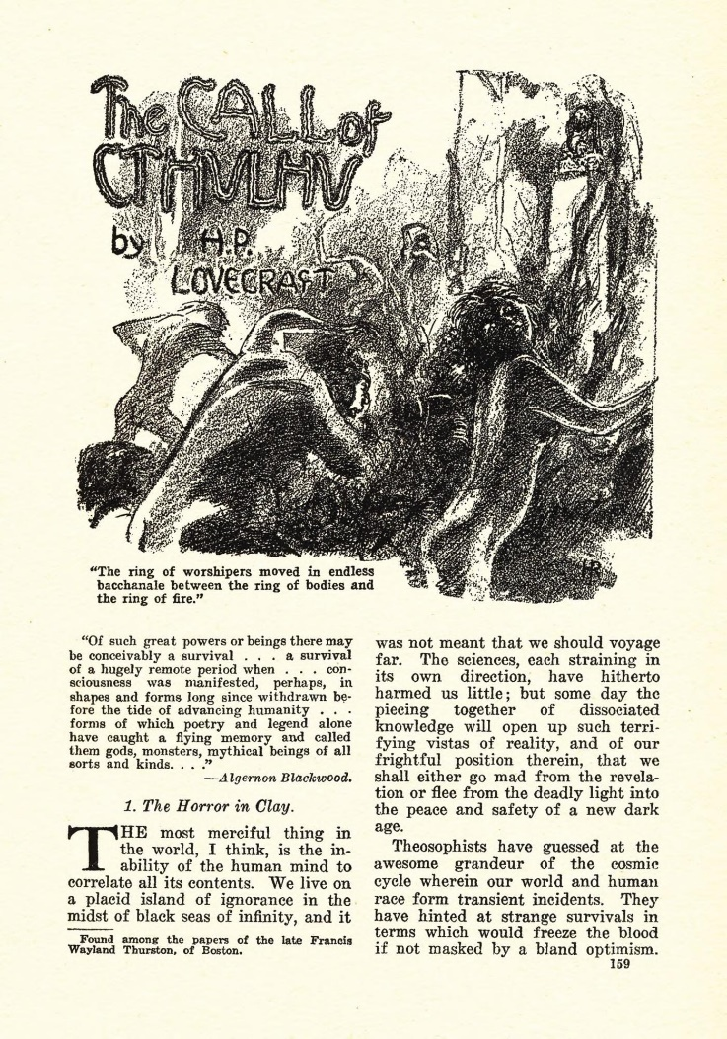
H.P. Lovecraft began his writing career just after the end of WWI, having most of his works published in the “Weird Tales” magazine. His style was marked by his poetic language, which drew inspiration from the stylized writing of gothic horror of which he was drawn to, with one of his favorite authors being Edgar Allen Poe. His stories, with their intricate imagery and prose, were all about the bizarre; he tackled topics such as self-immolation, cannibalism, homicide, aliens, cannibalism, and other things related to the grim and the occult. H.P. Lovecraft would wound up creating two new subgenres of horror fiction: Cosmic Horror and Weird Fiction, of which the latter he coined the term himself. This unique style of his and the atmosphere it invoked would be what propelled his stories into gaining traction, although he would only really get famous and achieve the prestige he is regarded with today after his death on March 15, 1937.
Title page of "The Call of Cthulhu" as it appeared in the Weird Tales Magazine, February 1928
Releasing a staggering 70 stories and multiple collaborative works over his lifetime, H.P. Lovecraft has marked the horror genre and created some of the most iconic creatures in fiction. The most famous example of this would be his short story “The Call of Cthulhu,” which features an ancient, squid-like, winged cosmic entity that has become synonymous with the author’s image and has had a multitude of reiterations made from it over the years. Other famous works of his include “At the Mountain of Madness,” “Nyarlathotep,” “The Colour Out of Space,” and “The Dunwich Horror.”
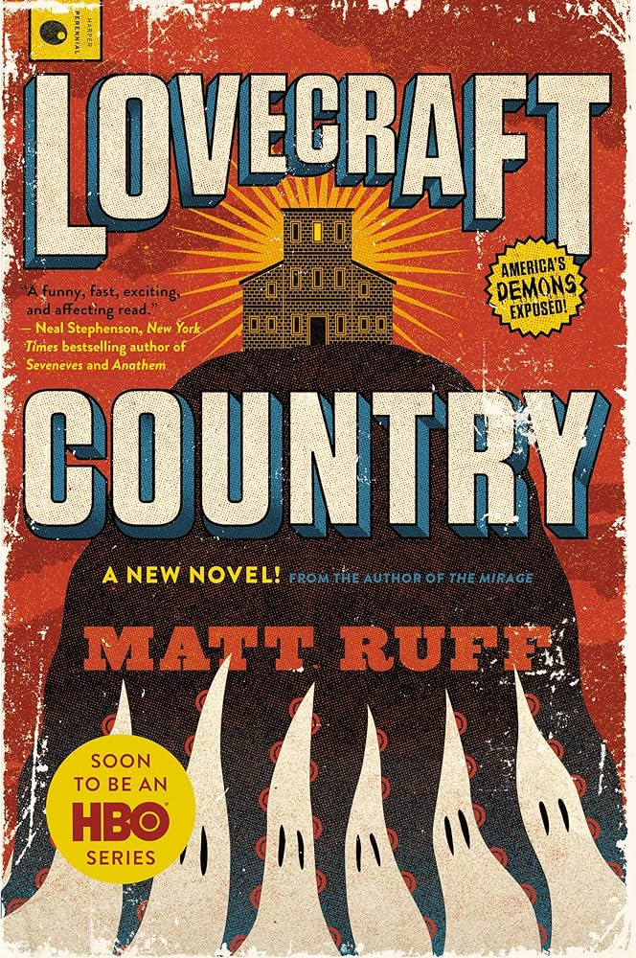
Many authors of modern horror have admitted to drawing inspiration from Lovecraft’s work, with notable ones being Junji Ito, Stephen King, and even high-fantasy author J.R.R. Tolkien. However, despite his influential and respected image as a classic horror author, Lovecraft has an undeniably horrible reputation tied to his works: his blatant racism. Known for embedding overt racist metaphors and literal stereotypes in his stories, Lovecraft was never shy about showing his opinions on white supremacy and the idea of racial crossing, even showing direct support of Hitler in letter exchanges with his friends. Among some of his famous works are “The Horror of Red Hook” and “The Shadow over Innsmouth,” which both include and center around racist metaphors. Yet, it’s not as if this dark part of his writings are completely shoved aside and ignored by communities — quite the opposite, in fact— as there have been multiple retellings made over the years that try and tackle the issues found in Lovecraft’s works. Namely, the HBO series “Lovecraft Country” is based on Matt Ruff’s 2016 novel that shines a light on his racist legacy and repaint the narrative to center on the black people that Lovecraft would villainize and mock in his own original stories. Another noteworthy adaptation of the sorts is “The Ballad of Black Tom,” a novella by Victor LaValle that retells the story of “The Horror of Red Hook” and analyzes the racist theme of the book through the lens of the “antagonistic” immigrants from the original story.
Nonetheless, H.P. Lovecraft’s works have been met with an overwhelmingly positive opinion throughout the centuries, having their fair share of impassioned adaptations and reviews made by adoring fans and watchful critics. So, to take a further look into the mind behind these tales and figure out more of what makes him so unique, H.P Lovecraft has agreed to sit down for an interview and answer a few questions about his creative process.
Paperback cover of Matt Ruff's "Lovecraft Country"

Chaves: How would you say your upbringing in Providence affect your writing?
Lovecraft: Well, I’d say I based off a lot of my stories’ settings on the geography of New England I’m familiar with, as well as the culture I grew up with mixed in with some of my own creative spin on it.

Chaves: Who would say were your biggest inspirations when creating your stories, and why?
Lovecraft: I quite like gothic horror, you see, and I was particularly drawn to authors who dabbled in that idea of our inherent existential dread as humans. There was Algernon Blackwood, M.R. James, Arthur Machen, Ambrose Bierce, just to name a few.

Chaves: You were quite involved with the community of pulp fiction of your time, were you not? How was it to collaborate and share ideas so closely with other authors who shared the same passion as you?
Lovecraft: Yes, I was indeed, and I surely enjoyed it interacting with my fellow writers. I believe that us creatives should encourage and inspire each other, and I often gave permission for others to write their own versions or take inspiration from my ideas and vice versa; it is the best way to foster new stories in my opinion.

Chaves: Could you explain why you were so focused in writing about the bizarre in your stories, rather than tackle more grounded topics?
Lovecraft: I’ll be frank, I am simply not interested at all in ordinary people. I see no reason to write about everyday scenarios that hold no allure to me. What I do gravitate towards is the unknown, the vast reality of time and space that we humans will never be able to truly comprehend. I was quite interested in astronomy as a kid you know, and I think that really fueled my interest in exploring this idea of the cosmos and its mysteries.

Chaves: It is said that you had night terrors as a kid, is that true? If it is, did it have any effect on your prose you could recall?
Lovecraft: Indeed, it is true; I began having them when I was about 6 years old. They did affect my writing in a way, as I wrote about some of the creatures that would appear in my dreams. You see, there were these things I called “nightgaunts” I saw quite often at night, and I made them into these faceless, pitch-black humanoids that would tickle their prey into yielding.

Works Cited
Cain, Sian. “ Ten Things You Should Know about HP Lovecraft.” Theguardian.Com, Guardian News & Media Limited, 20 Aug. 2014, www.theguardian.com/books/2014/aug/20/ten-things-you-should-know-about-hp-lovecraft.
Eil, Philip. “The Unlikely Reanimation of H.P. Lovecraft.” Theatlantic.Com, The Atlantic Monthly Group, 20 Aug. 2015, www.theatlantic.com/entertainment/archive/2015/08/hp-lovecraft-125/401471/.
“H.P. Lovecraft.” Britannica.Com, Encyclopædia Britannica, Inc., 17 Oct. 2023, www.britannica.com/biography/H-P-Lovecraft.
Romano, Aja. “Lovecraftian Horror — and the Racism at Its Core — Explained.” Vox.Com, Vox Media, 18 Aug. 2020, www.vox.com/culture/21363945/hp-lovecraft-racism-examples-explained-what-is-lovecraftian-weird-fiction.
Skinner, Caroline. “H.P. Lovecraft Research Project.” Prezi.Com, Prezi Inc., 24 Oct. 2018, prezi.com/p/cbxgsiwnuum3/hp-lovecraft-research-project/#present.
Soloski, Alexis. “Gods, Monsters and H.P. Lovecraft’s Uncanny Legacy.” Nytimes.Com, The New York Times Company, 7 Aug. 2020, www.nytimes.com/2020/08/07/arts/television/hp-lovecraft.html.
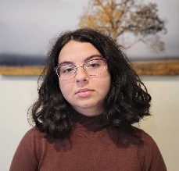
Anne Chaves is a Mandarin Junior who loves to read and draw. She has worked on many research projects over the years as a student and has dabbled in news reporting in the past. Follow along for more deep dives into literary works, analyses of authors and artists’ lives and careers, and reflections of life.

