The Skeleton That Changed Us All
THE CREATION OF JACK SKELLINGTON
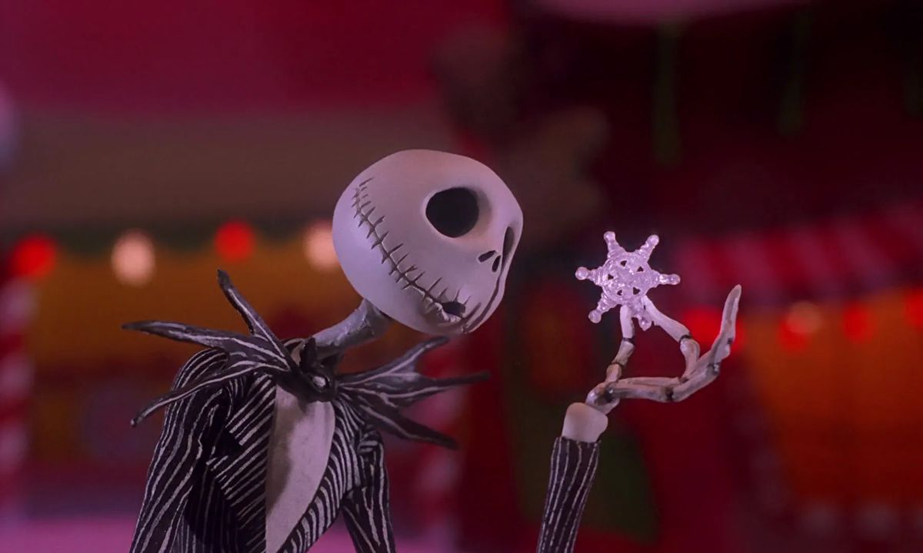
Gracie Edwards 10/30/23

Jack Skellington is from the 1998 film “Nightmare Before Christmas” directed by Henry Selick and created by Tim Burton, Jack Skellington has made quite a popular name for himself in the past 30 years.

The movie is derived from the famous poem “Twas the Night Before Christmas” and Jack himself was created from a poem that Tim Burton wrote himself, there was only supposed to be three characters from this poem, but for the movie the added more to make it more interesting.

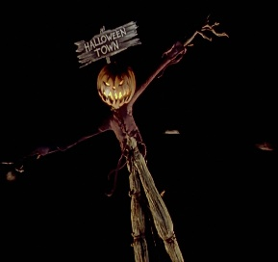
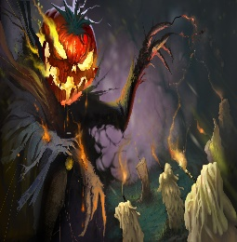
Jack Skellington was based off the Irish folktale Stingy Jack, who was turned evil and became the Pumpkin King, and now the mascot of All Hallows Eve. The parallels between him and Skellington are very similar because they both revolve around fire, and pumpkins.
People still celebrate Jack Skellington today by watching the movie “Nightmare Before Christmas” on Halloween and dressing up as him, making foods, and/or carving pumpkins to look like him!!!
SIMILAR RIGHT?!?!!? Stingy Jack (left) Jack Skellington (Right)

MOCK INTERVIEW WITH JACK SKELLINGTON
GE: “Hello Jack! How are you today?”
JS: “ Oh, I’m doing wonderful thank you. Are you excited for Halloween?”
GE: “You bet Jack!! We have some questions to ask you today! Are you ready?”
JS: “As ready as when I almost stole Christmas!”
GE: “anyways…”
- Q: How does it feel to know that people still celebrate you and your movie? For instance, there was a girl who did her face makeup like you, but with a twist. There are also people carving pumpkins to look like you and Sally!!!
A: It feels amazing, its nice to know me and my wife and friends are still prominent today especially after what I did to those poor kids on Christmas. Its so nice to see people carving pumpkins into me or something that represents me and my character. You know what they say, “ In a world of scary clowns and hideous zombies, theirs still room for the earnest but impulsive Jack Skellington from “Nightmare Before Christmas.”

- Q: So, I’ve heard that you’ve made some friends in the Disney realm. You were spotted in different movies other than your own, like “Princess and the Frog” and “Finding Nemo”, how did it feel to be included in those films?
A: It was so fun, I’ve made so many movie cameos in my time I cant even keep count. My first one was in Beetlejuice which was in 1988, then my most recent one in Wreck it Ralph Breaks the Internet in 2019, me and Sally were spotted all the way in the back in one scene.

- Q: Have you ever heard of Stingy jack? Hes an old Irish folktale that was inspiration for your design.
A: Me and him are great friends actually! We have brunch every Sunday before Halloween. Its understandable as to why people were so crude to him in the past, but hes a changed man now.

- Q: In the extended cut of the movie soundtrack, it is said that you have children!! Is that true?
A: I was waiting for this question, yes its true me and Sally have children together. We have 5 beautiful little gremlins and the all play together in a xylophone band.

- Q: Closing in on our final question which you do NOT have to answer, but we would like to know, how did you die?
A: Well, that got incredibly deep incredibly fast, also I have no issue answering this question but I appreciate asking beforehand! I was burned alive at the stake, hence why I renew myself after I was lit on fire at the beginning of the movie.
GE: “Thank you so much for taking the time to answer these questions for me, it was truly an honor to talk to you!!”
JS: “Oh, of course! I love doing these mock interviews with different people, its so fun!”
GE: “Well, I hope you have safe travels on your way back to Halloween Town, this is Gracie Edwards tuning out!”

BIBLIOGRAPHY:
- La Juenesse, Marilyn. “18 Things You Didn’t Know About The Nightmare Before Christmas.” Insider 14, Oct. 2022, www.insider.com/nightmare-before-christmas-facts-2018-9
- Brown, Heather. “Good Question: How did pumpkins become the symbol of Halloween?” CBS, 24, Oct. 2023. www.cbsnews.com/minnesota/news/how-did-pumpkins-become-the-symbols-of-halloween/?intcid=CNM-00-10abd1h
- “Fun Halloween Recipes Every Kid Will Love.” CNN Food Network Kitchen. 19, Oct. 2023, www.cnn.com/wbd/fun-halloween-recipes-every-kid-will-love/index.html
- Bremness, Rick. “Makeup Artist Takes on the Pumpkin King for Halloween” CBC, 13, Oct. 2017,ww.cbc.ca/news/Canada/Edmonton/makeup-artist-takes-on-pumpkin-king-for-halloween-1.4379243

MINI BIO:
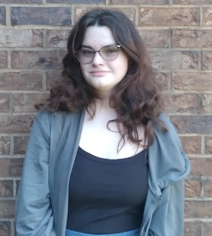
CLASS OF 2027, VOLLEYBALL PLAYER, FUTURE SURGEON
“Never wield such power you forget to be polite.” – Taylor Swift

