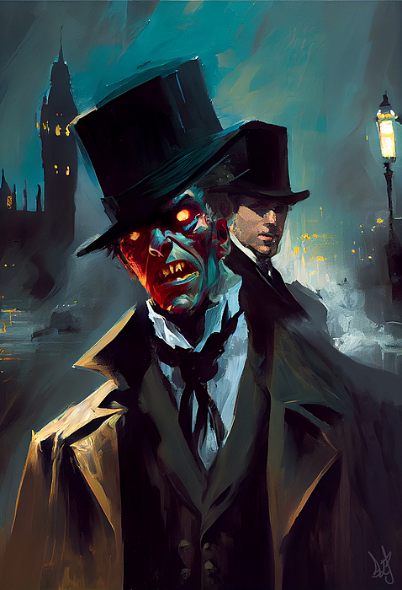
Two Sides of the Same Coin: Jekyll & Hyde
Figure 1 Visual art of Jekyll's stark contrast in self.
How man and monster are united and divided.
By ZARA GAJIC on OCTOBER 31, 2023
The story of Jekyll and Hyde is “one of the most [renowned] pieces of English literature,” even becoming a phrase to describe the stark contrast of one’s depth in personality (Wikipedia). The novel, “Strange Case of Dr Jekyll and Mr Hyde,” tells the story of a man with a split personality that takes over his life. The author, Robert Louis Stevenson, had been fascinated with double lives and double personalities since he was a young boy, even starting off his early career with a play centered around the interest. The play was based around a real-life scenario that inspired Stevenson about a man named Deacon Brodie who was a working family man by day, and abhorrent criminal by night; the man had been hanged for his crimes. The play, though unsuccessful, kickstarted Stevenson’s pursuit of the arts and led him to create what is now the embodiment of everything split.
Stevenson gathered the inspiration for the novel, published in 1886, from a ghoulish nightmare he experienced (Singh & Chakrabarti, 2008). The publication of the book, at the height of the Victorian Era, reflected Stevenson’s personal views on the religious aspects of human nature, blatantly delving into the angel and devil characteristics (Wikipedia). The audience of his works were delving into a novel that discussed such taboo topics of the time, part of the reason it interested the author so deeply.
“All human beings, as we meet them, are commingled out of good and evil: and Edward Hyde, alone, in the ranks of mankind, was pure evil.”
Robert Louis Stevenson

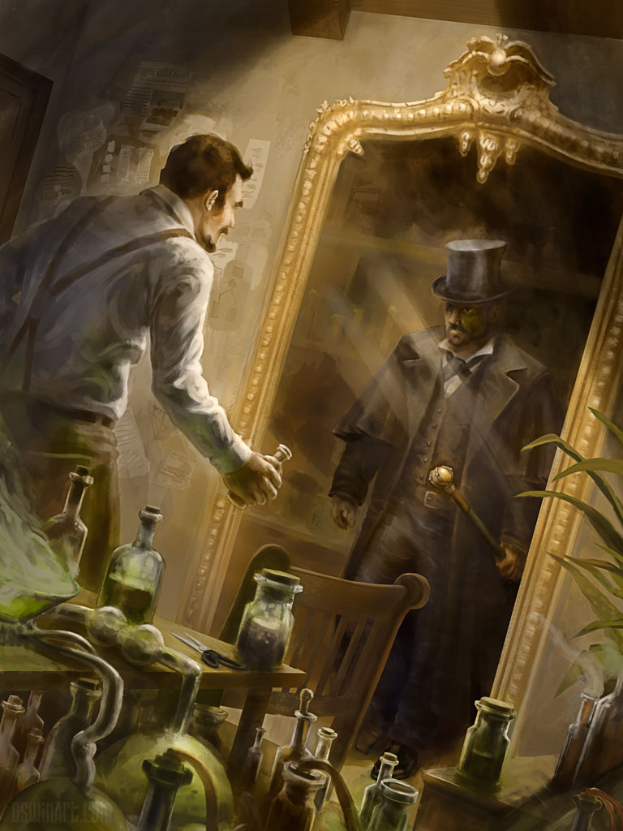
ADAPTATIONS
The novel was not only prominent in literature, but in media as a whole. The novel was adapted into a play and several films, along with audio book and video games. The signature ‘split’ design of characters is referenced everywhere: Green Goblin, Two-Face, Hulk & Bruce Banner, etc. But, aside from the media aspect, ‘Jekyll and Hyde’ had a colossal influence on the world of Psychology. The novel introduced an explanation for the duality of human nature (Singh & Chakrabarti, 2008).
PLOT SUMMARY
The tale is told from the realizations of one ‘Mr. Gabriel John Utterson,’ a close friend and lawyer of Dr. Jekyll’s. In the beginning of the novel, Mr. Utterson learns of a heinous criminal, by the name of ‘Mr. Hyde,’ who had trampled a young girl. The man, he learns, was forced by a ‘Richard Enfield’ to pay the young girl’s family as an act of severance (Wikipedia). The payment is signed by Dr. Jekyll and Mr. Utterson begins to wonder about the connection between the two. As time goes on, Mr. Utterson can never seem to interact with both Jekyll and Hyde, only separate, and only months apart, and Mr. Hyde’s crimes have become murderous. It is then revealed through ‘Mr. Lanyon’ and Jekyll’s letters that Hyde and Jekyll are the same, changed only with a potion. Finally, the truth is somewhat revealed, and Mr. Utterson is in shock. He reads on, learning that the potion controlling the dominance between the two and had been originally invented to separate the hellish aspects of Jekyll’s personality (Britannica). His alter ego, Hyde had been growing in power and eventually, the ingredients for the potion diminished entirely. By some miracle, more than enough ingredients have been rediscovered to establish this interview:
Figure 2 A depiction of Dr. Jekyll and Mr. Hyde; a depiction of one's hidden "inner" self.
GAJIC: Good evening to you, sir. Regardless of who I’m speaking to, I’d like to preface this by informing you that I intend to speak to both Dr. Jekyll and Mr. Hyde today.
???: Yes…I suppose so.
GAJIC: I’d like to let you know that there are many portions of the potion but, for time’s sake, I’d prefer to only have to use it once. Now, I apologize, but you are Dr. Jekyll, correct?
JEKYLL: Yes, it is Dr. Jekyll, at the moment.

GAJIC: How convenient. Let’s start this off with an easy one; you and Mr. Hyde are both you essentially, yes? So, what makes you two different?
JEKYLL: Well, aside from the obvious physical difference: I am blessed with looks and smart and wit, while Mr. Hyde is (ahem) less fortunate, we are driven by two entirely different forces, and his is pure evil.
GAJIC: Of course, understandable. Now, I assume, since he was once your darkest thoughts, you must harbor some amount of compassion for him, or do you renounce him entirely?
JEKYLL: It is indeed difficult to say. Of course, selfishly, I care for him in a way one would care for themselves and their greed. Morally, however, he is unpredictable and crazed. When he loses all sense, I don’t know how to go about it…I’m afraid.
GAJIC: And to dig more into that, what exactly is it that you’re afraid of? Are you, perhaps, afraid that if he is capable of such despicable acts then you must be as well?
JEKYLL: Yes, well, it is a difficult road to approach, sense of self, that is. I wish to say he is nothing like me and I wish to dispose of him completely. But he is me, and I am him, and that is what I fear most. It’s not my unknown capabilities but instead, my undiscovered anger. I’m afraid of where it surfaces from.
GAJIC: (holding potion) Well, I’m afraid to do this but I’d like to speak to Mr. Hyde if I may.
JEKYLL: Of course, but I must warn you to not provoke him. He
can be tame, at times.
GAJIC: Mr. Hyde? Mr. Hyde, are you well?
HYDE: Oooo…(laughs) I am well, Miss.
GAJIC: Right, this will be quick, I promise. I just have a few
questions that need answering.
HYDE: Well?
GAJIC: Mr. Hyde, what is it that you fear?
HYDE: Foolish, foolish girl, I fear nothing.
GAJIC: Nothing at all?
HYDE: Nothing. Men fear me, and they should continue to, for
a man who fears nothing is the worst of all.
GAJIC: Yes, but of course, it can be argued that fearing nothing, in turn, makes you nothing. Would you agree, Mr. Hyde?
HYDE: I would not! I am not nothing! I am the very basis of what anything is! Everything on this unfortunate planet evolves from me! From anger and greed and selfishness. I am not nothing, I am the most important of all!

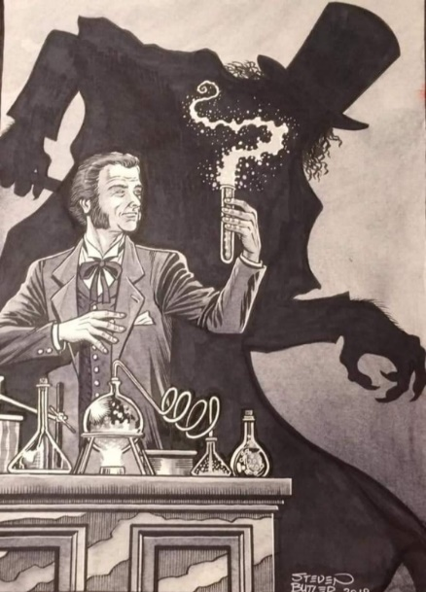

Figure 3 Dr Jekyll has created the potion that will transform him into the monstrosity behind him.

Ever so on edge, and ever so elegant, Dr. Jekyll and Mr. Hyde cannot exist without the other. They are relative to one another and would never be honored or degraded if they existed alone. It is together that they can create harmony and balance throughout all.

Works Cited
“Strange Case of Dr Jekyll and Mr Hyde.” En.Wikipedia.Org, Wikipedia®, 31 Oct. 2023, en.wikipedia.org/wiki/Strange_Case_of_Dr_Jekyll_and_Mr_Hyde.
“The Strange Case Of Dr. Jekyll And Mr. Hyde Quotes.” Bookroo.Com, © 2023 Bookroo, bookroo.com/quotes/the-strange-case-of-dr-jekyll-and-mr-hyde. Accessed 31 Oct. 2023.
Brown, Dr. Stephen. “The True Story Behind the Story of Dr. Jekyll and Mr. Hyde.” Trentu.Ca, @ Copyright 2023 Trent University, 31 Oct. 2022, www.trentu.ca/news/story/34751#:~:text=In%20the%20late%201700s%2C%20Brodie,just%20about%20an%20interesting%20character.
Lebeau, Vicky. “The Strange Case of Dr. Jekyll and Mr. Hyde Novella by Stevenson.” Britannica.Com, Encyclopedia Britannica, 10 Aug. 2023, www.britannica.com/topic/The-Strange-Case-of-Dr-Jekyll-and-Mr-Hyde.
Pendergast, Sam. “Characters That Are Directly and Indirectly Inspired by Dr. Jekyll and Mr. Hyde.” Editions.Covecollective.Org, COVE Studio, 21 Nov. 2022, editions.covecollective.org/content/characters-are-directly-and-indirectly-inspired-dr-jekyll-and-mr-hyde.
Singh, Shubh M., and Subho Chakrabarti. “A Study in Dualism: The Strange Case of Dr. Jekyll and Mr. Hyde.” Ncbi.Nlm.Nih.Gov, © 2008 Indian Journal of Psychiatry, July 2008, www.ncbi.nlm.nih.gov/pmc/articles/PMC2738358/.

─── ⋆⋅☆⋅⋆ ───── ⋆⋅☆⋅⋆ ───── ⋆⋅☆⋅⋆ ───── ⋆⋅☆⋅⋆ ───── ⋆⋅☆⋅⋆ ───── ⋆⋅☆⋅⋆ ───── Zara Gajic is a high school student dedicated to her studies and (more often) her friends. She loves to keep up with all things trending and is frequently watching and listening to new media. Most of all, especially depicted in her writing, she loves music. ─── ⋆⋅☆⋅⋆ ───── ⋆⋅☆⋅⋆ ───── ⋆⋅☆⋅⋆ ───── ⋆⋅☆⋅⋆ ───── ⋆⋅☆⋅⋆ ───── ⋆⋅☆⋅⋆ ─────

