Formatting
- Heading at the top Left-20-24 pt font
- Sub-Heading Directly Below that
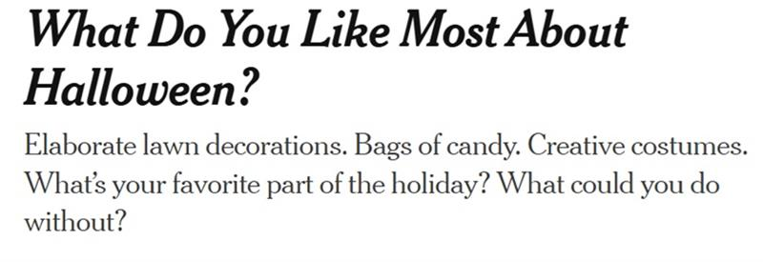

*Picture to the Top Right With Caption
By Jeremy Engle
Oct. 30, 2024Updated 12:40 p.m. ET
- By-line that has your 1st & Last Name and the Spelled-out date
- The Rest of the Body of the article should be 12 pt Times New Roman

Sources
- MUST be Referenced in the article, EX: Our upcoming celebration of Halloween according to the New York Times, "has transformed from a pagan feast...to one of the largest consumer spending holidays," showing how the United States has turned even a frolicking evening of small children into a reason to buy more goods.
  - Quotes should be sandwiched-like an Oreo Cookie, within YOUR writing
    - Original Quote that I Shortened (the goals is 10 words or less, I do give some leeway: "Halloween, steeped in tradition, has transformed from a pagan feast to a celebration with lovingly homemade costumes and treats to one of the largest consumer spending holidays in the United States."
  - Make sure you connect that reasoning as to how this quote is supporting the bigger idea of what your article is about.
- MUST have all Sources Cited in MLA Format, here is the article I used in both MLA & APA so you can see the key differences
  - MLA: Engle, Jeremy. “What Do You Like Most About Halloween?” Nytimes.Com, The New York Times, 30 Oct. 2024, www.nytimes.com/2024/10/30/learning/whats-your-favorite-part-of-halloween.html. In this article I found out that the US once thought that Halloween was a passing holiday that would go out of fashion. I plan to use it to show how it has moved from a family centric pastime to a consumer driven money-based experience.
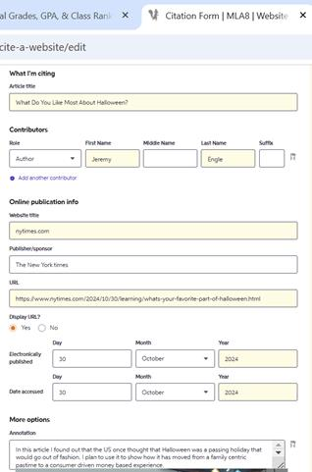
  - APA: Engle, J. (2024, October 30). What Do You Like Most About Halloween?. nytimes.com. https://www.nytimes.com/2024/10/30/learning/whats-your-favorite-part-of-halloween.html In this article I found out that the US once thought that Halloween was a passing holiday that would go out of fashion. I plan to use it to show how it has moved from a family centric pastime to a consumer driven money-based experience.
- LOOK  at the Differences in the Formatting! This is something that is important, if you cite sources wrong it can look like you plagiarized when you didn't.
- This is what EACH SPACE on Citation Machine Should look like:
Mini Bio
- 3-5 Sentences about you, should FILL the space by your picture
- Professional looking headshot, Tight to the Bio Information

Remember-CH 3 make sure your article is timely, relevant, and has a reason for coverage. I HIGHLY recommend the CNN10 News topics as a starting point! https://www.cnn.com/cnn10

The Above at the REQUIRED Items, IF all items are included then the article will be graded based on the following criteria:
