Complete the Inverted Pyramid from pg 129-GENERALIZE the Specifics that they put in about the Football Game:
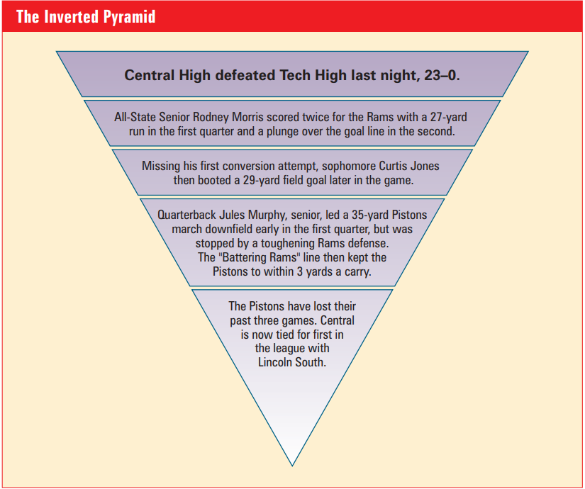

A key name, with an event, and later result towards the outcome of the game

The Kicker: Final Result & why we should look for more updates

AP Leads-Find the Key Elements of the Lead Statement and annotate them with the following text marks:
(Who) What When [Where] Why How
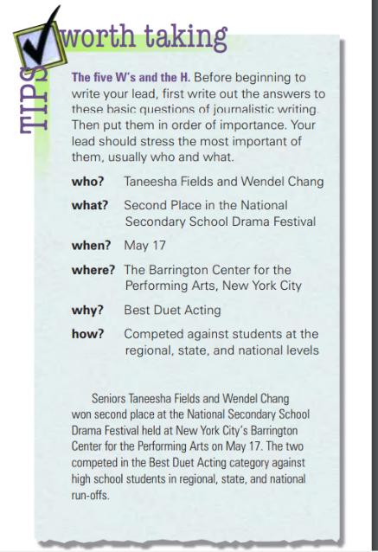
- A three-alarm fire Friday destroyed several fuel-storage tanks just outside Centerville, injuring three firefighters and causing an estimated $1 million in damage.
- Seniors Jaime Garcia and Mary Jo Shanahan were named King and Queen of Homecoming on Nov. 12.
- An airplane bound for New York City skidded off the Cedar Rapids Airport runway Tuesday, injuring three passengers slightly.
- With a key win against Lockport, the varsity girls’ team snapped a three-way tie for the SCIA title two weeks ago, then claimed sole possession of it when Romeoville defeated Joliet Central last week.
Complete the Questions on Creating Leads:
- Compare these 2 Creative leads:
Lead | Did Well | Issue
Arthur Learned, 42, has been named drama coach at North High School.
An Air Force flier with a closetful of medals is the new drama coach at North High School.
- What’s wrong with the following lead (see details on Pg. 133) : At long last, the citizens of Smithville opened their pocketbooks in recognition of the value of education. Yesterday they demonstrated their faith in the youth of America by approving a $5-million bond issue for a new high school.
____________________________________________________________________________________________________________________________________________________________________________________________________________________________________________________________
Finding the Right Lead
- What are the 6 types of Leads that are taught: ______________________, _______________________, _____________________, _________________________, _________________, _________________.
- What are the 4 items that you REALLY need to remember in creating a Lead? ____________________, ______________________, _____________________, & ____________________________________.
- Complete the following statement: “The bottom line is that you need to make the lead ______________________________. Write it as well as you possibly can and then________________. Writing is ________________; this is particularly true of leads. Seldom is the _________________ that pops into your head the ________________.
Good Leads (Pgs. 135-139)
Read the samples on these pages & write the 3 Best leads that could inspire you:
- ________________________________________________________________________________________________________________________________________________________________________________________________________________________________________________________________________________________________________________________________________________
- ________________________________________________________________________________________________________________________________________________________________________________________________________________________________________________________________________________________________________________________________________________
- ________________________________________________________________________________________________________________________________________________________________________________________________________________________________________________________________________________________________________________________________________________
Sample of a Good Lead Revision:
The Original (NASA) | Sam Seabourne-White House Speech Writer
"Good morning! I'm speaking to you live from the West Wing of the White House. Today we have a very unique opportunity to take part live in an extremely historic event which..." | "Good morning. Eleven months ago a 1200 pound spacecraft blasted off from Cape Canaveral, Florida. Eighteen hours ago it landed on the planet Mars. You, me, and 60,000 of your fellow students across the country along with astro-scientists and engineers from the Jet Propulsion Lab in Southern California, NASA Houston, and right here, at the White House,  are going to be the first to see what it sees, and to chronicle an extraordinary voyage of an unmanned ship called Galileo V."

