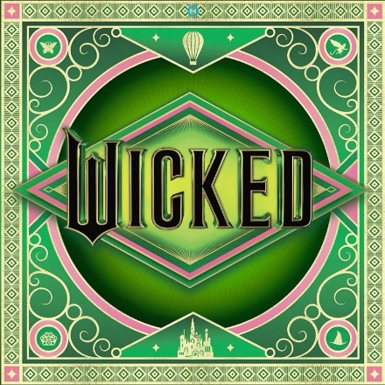
'Do Us Good'
written by
Amanda Gorman
Are we
born wicked or
do we have wickedness thrust upon us?
Are we born bad, or brave?
There is a world we miss when we misbehave,
But we miss just as much when we misconstrue.
When we distrust what is different, and detest what is new.
History is written by the victors,
and villains are embittered by the forcible and the few.
But through how we live, our children learn:
What we earn when we're earnest
and what we forge when we forgive.
Only with a decency do we discover:
People are not born evil,
we are born equal;
Green,
not with envy, but what we envision in each other:
A sentimental mankind finding ourselves even in the dark.
There is a goodness that knows in our hearts,
No one is wicked at birth.
We are born to light the wick of the earth.
We are all that girl:
When something changes within us,
something changes in this vast world.
We will never be the same;
This feeling, fervid as a flame has a name:
Unadulterated loving;
Rushing,
Flooding.
Together we will stare down the emerald tower;
We will not cower.
We will not let our power take over us.
But let ourselves take back our power.
We won’t just say we're sorry now.
Rejoicify that we're glad and grateful just to be seen and not listened to.
We'll dream, soar into the blue, rise up to a new reality,
Because defending the good is how we defy gravity.
So if you dare to find us, look to our West-turned eyes!
Everyone won't do good deeds.
But all deserve the chance to try;
To be understood as we should.
And if this they would mourn as wicked.
Then let this wicked do us
good.
Response: (Using the poem and one of the secondary sources #1-3, respond in a Detailed Paragraph one of the questions below)
- Anne Frank wrote, "I still believe, in spite of everything, that people are truly good at heart" in her diary on July 15, 1944.
- In Chapter 1, Gatsby is described as having an “extraordinary gift for hope,” meaning that he has a sensitivity to life and a sense of its possibilities that surpass those of others.
- At the beginning of the year, we discussed the story of “The Butterfly” and how to be successful one has to struggle, what similarities do you see between that story & this poem?
- Do you agree or disagree that people are born good?
- Do you feel the current generation has the same values as previous generations? Why or Why Not?
- What situation(s) have you experienced that you have felt misunderstood?
- If you could get people to listen, what would you want them to hear about you?

