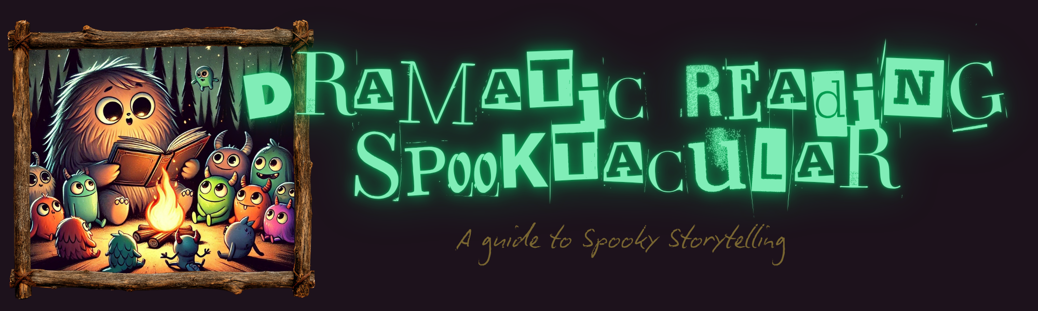
Project Directions
In this project, you will select a spooky short story and perform a dramatic reading for the a small group in the Library. Your goal is to create an engaging and chilling atmosphere through your voice, pacing, and character portrayal. Get ready to unleash your inner ghoul!
Story Title: ____________________________
Author: ____________________________
Choosing Your Spooky Story
Not all stories are created equal when it comes to dramatic readings. Look for tales with:
- Vivid Descriptions: Passages that paint a clear picture of the setting and events.
- Suspenseful Moments: Points in the story where the tension builds and keeps the listener on edge.
- Interesting Characters: Individuals with distinct personalities that you can embody.
- Dialogue: Conversations between characters that allow for varied vocal expressions.
Rubric: Dramatic Reading Performance
Use the rubric below as a guide to prepare your best dramatic reading. It outlines the criteria for success, focusing on key aspects of your performance.
Criteria | A (Excellent) | B (Good) | C (Fair)
Voice & Expression | Uses a wide range of vocal tones, volume, and pacing to create a captivating and expressive performance. Voice matches the tone of the text very well. | Uses varied vocal tones, volume, and pacing effectively. Voice generally matches the tone of the text. | Demonstrates some variation in vocal tones, volume, and pacing. Voice sometimes matches the tone of the text.
Character Portrayal | Embodies characters convincingly through distinct voices, mannerisms, and emotional expression. | Portrays characters with some differentiation in voice and emotional expression. | Shows limited differentiation between characters. Voice and emotional expression are mostly uniform.
Pacing & Timing | Uses pauses, changes in speed, and dramatic timing to enhance suspense and create a captivating narrative flow. | Demonstrates good control of pacing and timing. Uses pauses and changes in speed appropriately. | Pacing and timing are somewhat inconsistent. Pauses and changes in speed are not always effective.
Clarity & Pronunciation | Pronounces words clearly and articulates effectively. Easy to understand every word. | Pronounces words clearly. Generally easy to understand. | Pronunciation is sometimes unclear. Occasional difficulty understanding words.
D (Needs Improvement): A 'D' will be given if the dramatic reading does not meet the minimum requirements in several criteria. Significant improvement is needed in voice, character portrayal, pacing, and clarity.
Project Timeline: Next Steps
10/16: Intro to the Project
10/20: Final Story Selections, Begin Annotations
10/24: Story Analysis Questions, VIDEO: Recording of Your Story
10/28: Final Practice Day (Peer Review Sheet)
10/30: S’mores & Stories in the Library!

