Halloween: A complete guide to horror’s quirkiest, most erratic franchise
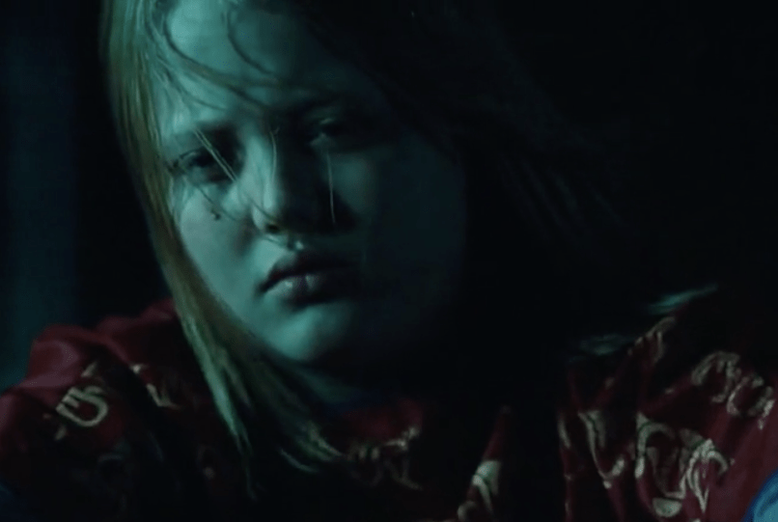
John Carpenter’s 1978 movie spawned a cat-and-mouse battle between Michael Myers and Laurie Strode that’s lasted four decades.
by Aja Romano
Updated Oct 13, 2022, 11:03 AM EDT
Michael Myers before the mask. Universal
The tale of Halloween in Haddonfield, Illinois, has been told and retold: the night in 1963 that an angelic 6-year-old Michael Myers, dressed in a clown suit, brutally murdered his teenage sister, followed by the night 15 years later, again on Halloween, when he broke out of a mental institution in his famously mutilated William Shatner mask to terrorize the virginal babysitter Laurie Strode, a.k.a. Jamie Lee Curtis in the role that would make her the ultimate scream queen.
As Laurie, Curtis has battled the unkillable, silent but single-minded Michael Myers across seven of the 13 films in John Carpenter’s Halloween franchise — including the newest trilogy, a trio of revamped sequels that kicked off in 2018, reenvisioning Laurie’s adult life but still showing her haunted and stalked by the killer. Directed by David Gordon Green, the (alleged) final installment in the trilogy, Halloween Ends, arrives this weekend.
The new film shows Laurie, now with decades of experience behind her, watching and waiting for Michael to return for one last round of leisurely unstoppable violence.
Of all iconic horror franchises, none is quite as quirky and erratic as this one. Though the original film, Halloween (1978), is Carpenter’s signature film, it’s the only one in the series he directed.

Aja Romano wrote about pop culture, media, and ethics. Before joining Vox in 2016, they were a staff reporter at the Daily Dot. A 2019 fellow of the National Critics Institute, they’re considered an authority on fandom, the internet, and the culture wars.

