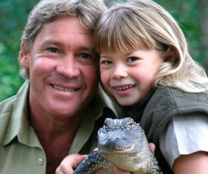
Bindi for Steve Irwin https://www.youtube.com/watch?v=P5pBN3cE-2A
What did she love about dad, what did he do, gives reasons why he was remarkable, how she remember him, what we will do from this

Sam for Aeon Eulogy GOT: https://www.youtube.com/watch?v=ygarLybuzrw
gave background, what was his credentials, 3 list of his positive qualities, what did he do in his years of service, gave metaphor about his life
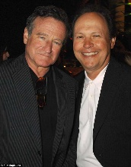
Billy Crystal for Robin Williams: https://www.youtube.com/watch?v=wgNgwFcLy90
Heartwarming intro, gave listed reasons as to why he was awesome, gave self connection, made a bit of a joke, told a story about a time where he was not quite perfection but rose to the occasion, personal connection friend to family, gave connection to job, used metaphor
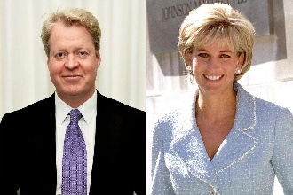
Charle’s Spencer, bother of Princess Diana: https://www.youtube.com/watch?v=NOtDI_coe2g
Starts with Family, country, then world, pay our respects, acknowledging audience, gave time of death, gave positive qualities, gave connections beyond self, why we are there, reactions of the remaining & how we will move forward, how are they real, the gifts of the person, list good works, notes flaws, give a self connection moment, noted family memories both young and old, admonishing of those that were not good to her, metaphor of her name, mission to go forth, connects to her children, ends with thanks for her life.
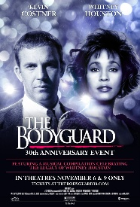
Kevin Costner for Whitney Houston (1st 7 min): https://www.youtube.com/watch?v=2wjh0N1EzPI
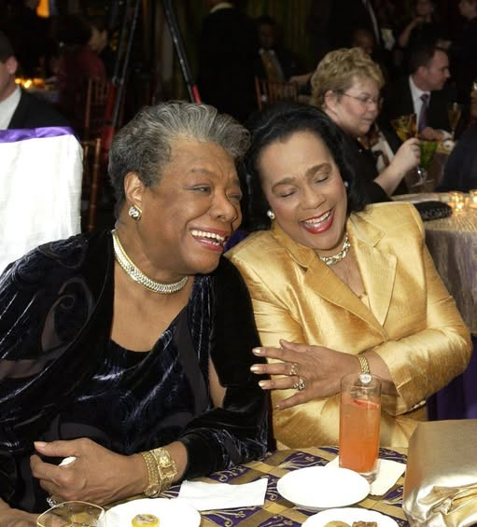
“I will always love you”-reference to song in movie they did together, addresses audience, remember to family that is present, connections between them, building a church- tells a bit of a joke, doing shots from communion, connecting to the dead, listing her accomplishments
Maya Angelou for Coretta Scott King: https://www.youtube.com/watch?v=otGXTryeY6w
Starts with a Spiritual Song, gave connection to the historical significance of Mrs. King, connected to her bigger purpose, what she did to help many people, noting why she should be remembered, gave back history, made a metaphor of her life changes, listed family & loves, discussed her big heart, gave personal connections, made audience laugh, references other prominent people that would remember the dead, peace and justice and why her message mattered, what are the bigger reasons that we should do something to make the dead proud.
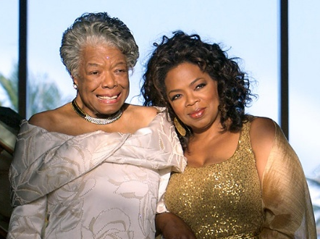
Oprah Winfrey for Maya Angelou https://youtu.be/C2s-1050fWE?t=36
Starts with a quote "God put a Rainbow in the Sky," talks about a time where she called for support, but brought it back in, showed the advice given, there for her, it's ok to sincerely be choked up, reflecting on other life experiences, gave history of friendship, gives humorous situation, "stand still inside yourself and know yourself," reflect on end of life, gave person backstory, gave examples of her importance, referenced a specific writing, quoted from writings, the first meeting, the building of her relationship and her importance to life, how she taught meaning to another's life, what is the legacy we can pass on.

