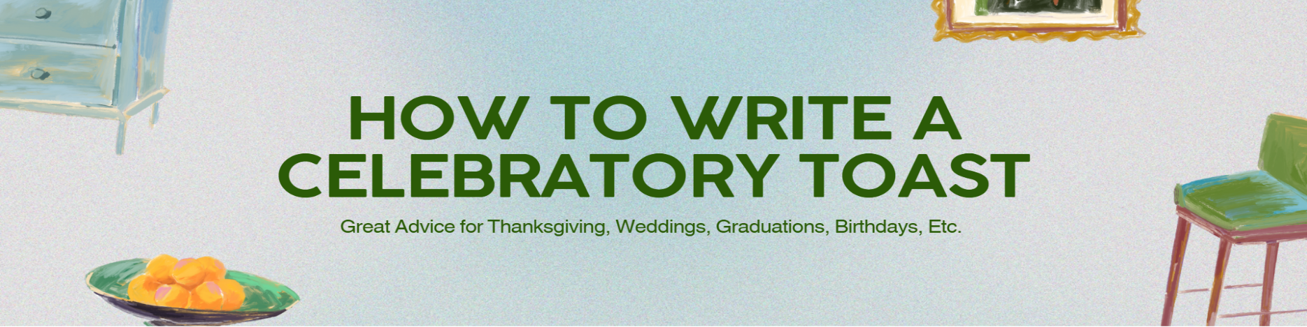

Part | Key Information to Plan | Notes/Brainstorming | MY Toast
Pre-planning | Person | Think of who in your family, friends, mentor, coaches, teachers, etc that you would like to toast.
Pre-planning | Event | What is the Occasion? Why is everyone gathered together for this event? (EX: Holiday, Birthday, Wedding, graduation, sporting win, etc.)
Introduction | Hook the audience and state your relationship to the person/people being toasted. | Start with a relevant story or a simple statement. "Hi everyone, I'm [Your Name], [Your Relationship] to [Person/Couple's Name]..."
Theme/ Main Idea | A single overarching theme or core idea about the person/people you are toasting. | E.g., "resilience," "kindness," "adventure." All stories should link back to this.
Body (Anecdote 1) | A short, visual story demonstrating the theme. | Describe the situation before this person's impact and the aftermath, highlighting their qualities. Keep it appropriate for all audiences.
Body (Anecdote 2) | A second brief story if needed to support the theme. Either something funny or endearing. | Ensure it is concise and avoids dwelling on details unfamiliar to most guests.
Conclusion/ The Toast | A final summary of good wishes, the "call to action" to raise glasses, and the final toast phrase. | Use a quote or a simple wish for their future. The final toast should be a short, clear phrase (e.g., "To a long and happy life together!").
Tips for Using Your Organizer
- Use bullet points, not a full script: This helps you sound natural and authentic, rather than over-rehearsed.
- Keep it short: A good toast should be brief, ideally no more than 3 minutes.
- Practice: Rehearse several times to ensure smooth delivery and good timing.
- Focus on the positive: Be sincere, complimentary, and uplifting.
- Raise your glass: Remember the physical action of raising your glass near the end of the conclusion, inviting others to do the same.
Breaking down the Timing
- Opening Moment: make a great first impression (5 seconds)
- Tell a story, reveal a shared problem (45 seconds)
- Help the audience know how to feel (20 seconds)
- Transform the audience (10 seconds)
- Close with grace (10 seconds)
That’s it! hit these moments and you’re all set. Additional Examples on the Class Website.

