Directions: In preparation for your Final Magazine Project, you will be Analyzing the elements of 2 New York Times UpFront Magazines to identify the parts that will be expected in your Finished Publication.
Publications | March 16, 2026 Issue | February 16, 2026 Issue
Front Cover Items | 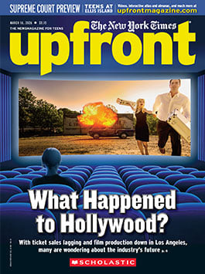 | 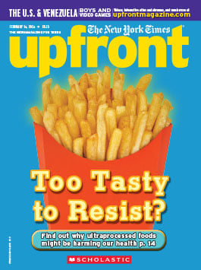
What is the Title of the Feature Article in the Issue?
What is “Finger Theme” does this article address?
Sum up the Introduction of the Article, how do they introduce the Topic?

What are 3 Key Sections/Features in the Article? (Subtitles, Images, Data, Etc) | 1-  2-  3- | 1-  2-  3-
Key Quotes: What would you Pop out as a Key Detail that is NOT Already Quoted. Write it here with Section & Paragraph #
What would be a good Follow-up question about the article if they were to revisit it?
2nd Article
Which article would you consider to be the most important LONG ARTICLE after the Cover Story?

What is “Finger Theme” does this article address?
Explain why you would rate this article as the 2nd most important one to read?
Sum up the Introduction of the Article, how do they introduce the Topic?

What are 3 Key Sections/Features in the Article? (Subtitles, Images, Data, Etc) | 1-  2-  3- | 1-  2-  3-
Key Quotes: What would you Pop out as a Key Detail that is NOT Already Quoted. Write it here with Section & Paragraph #
What would be a good Follow-up question about the article if they were to revisit it?
The Big Picture
What is “The Big Picture story about?

What is “Finger Theme” does this article address
Sum up the Article, how do they give evidence about the Topic?
Does it cover the 5Ws & How?
One Key item that could be quoted in this piece?
Additional Articles: Find additional Short or Long Articles that will Cover the Remaining “Finger Themes”
Additional Article 1 Title
Short or Long (Multi-Page) Article?
Theme
Sum up the Article, how do they give evidence about the Topic?
One Key item that could be quoted in this piece?
What would be a good Follow-up question about the article if they were to revisit it?
Additional Article 2 Title
Short or Long (Multi-Page) Article?
Theme
Sum up the Article, how do they give evidence about the Topic?
One Key item that could be quoted in this piece?
What would be a good Follow-up question about the article if they were to revisit it?
Additional Article 3 Title
Short or Long (Multi-Page) Article?
Theme
Sum up the Article, how do they give evidence about the Topic?
One Key item that could be quoted in this piece?
What would be a good Follow-up question about the article if they were to revisit it?
The Debate
The Question

The Writer Of the YES Side
The Writer of the NO Side
How do they SUPPORT their Side?

Does EITHER SIDE Show Bias?

The Back Cover
What is on the Back Covers?

How Many?

What do some of them relate to?
Final Reflection | Are there any articles that you would use as final topic ideas for your Magazine? | What Questions do I have on the Final Exam Project?

