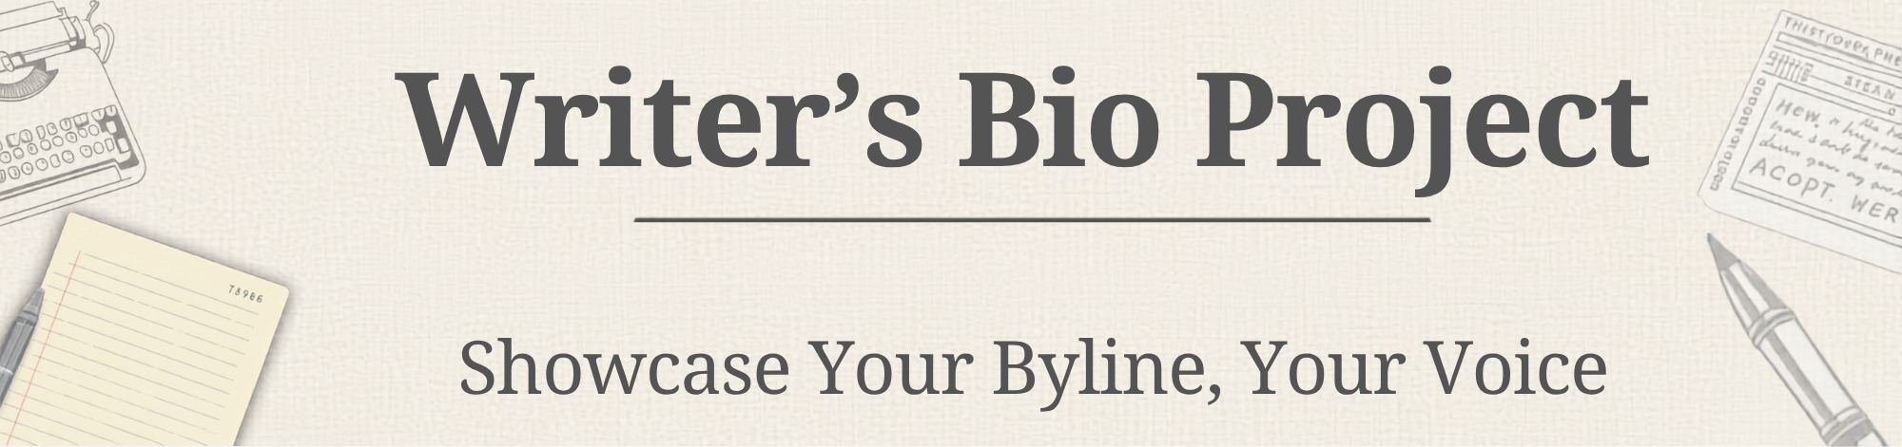

The Key Idea
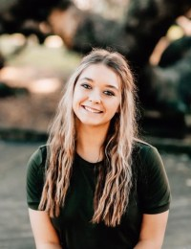
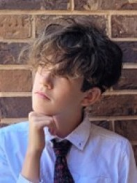
A Writer’s Bio is a more conversational version of a traditional resume. For this project, you will include some of those traditional items:
- A Professional-Looking Headshot (Not a Selfie)
- Contact Details
  - Address: You are an MHS Reporter, so the address will be the school’s
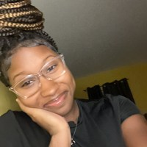
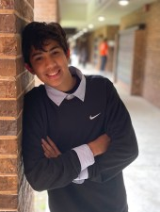
    - 4831 Greenland Rd
Jacksonville, FL 32258
  - Email: S+ Your Student Number@students.duvalschools.org
  - Phone: The School Number 904-260-3911
- Experience
  - What are some of the things that you have been involved in:

    - Projects
    - Articles
    - Writings
    - Activities

  - Or background that could influence you as a writer (See List on the Back of this Page):
Formatting Suggestions:
- Use a template in MSWORD, search for: Resume with Picture
- Use a Resume Template in CANVA
- Name should be the Largest, Boldest Font
- Title your sections (14-16pt font in WORD-Canva it Varies, but make it readable)
- Body of Text (10-12pt Font)-Don’t go too Small, but 1 Page Front Only
Project Timeline:
- Week 1:
  - 8/18: Tuesday-Intro to the Project & Begin Planning
  - 8/19: Wednesday-Review Sample Bios for Style & Details
  - 8/20: Thursday-Headshots Due/Taken in Class & Start Drafting Your Bio (Use a Resume Template-Bring Laptop)
  - 8/21: Friday-Working Day in the Newsroom for Bios (Bring Laptop)
- Week 2:
  - 8/18: Tuesday HOMEWORK-Upload Draft of Bio to Focus so I can print it!
  - 8/19: Wednesday-Peer T.A.G. Reviews & Editing on paper copies
  - 8/20: Thursday-In-Class time for Final Editing on your Bio (Bring Laptop)
  - 8/21: Friday- HOMEWORK-Writer'sBios due to Turnitin Tab on Teams by 11:59 pm TONIGHT!!
List of Possible Topics
Just the basics. Make a list of the basic facts of your life, facts that you don’t mind sharing. (Age, parents, brothers and sisters, pets, phone number, address, hair color, eye color, height, weight, birthday, city of birth, religion, communities where you have lived, etc.)
Me, in a nutshell. Give a brief description of yourself. Who are you? What are you like? What are your major activities and interests? What is important to you? What is important to know about you?
When I was small. What were you like when you were very young — from birth to about five years old? (You may later want to ask family members for help here.) When and where were you born? What kind of baby were you? When did you first talk? What were your favorite toys, songs, games or bedtime stories? What do you remember about day care or baby-sitters?
My early childhood. What were you like from about ages six to ten or eleven? What is your first memory of school? What was your favorite school subject? How did you spend your free time after school and on weekends? What changes occurred in your life?
Little known facts about me. List some facts that most people don’t know about you. (Places you have lived, awards you have received, famous people you have met, famous people you are related to, unusual events in your life, etc.)
My favorites. Make a list of your favorites. (Favorite after-school activity, dessert, sport, holiday, music group, friend, book, movie, quotation, TV show, place to walk, fast food restaurant, month, singer, actor, school subject, song, etc.)
What I’m proud of. What accomplishments are you proud of? (Improving your grades last year, giving a speech for the student body, getting the courage to try hang-gliding, etc.) What awards have you won? (In school, sports, church groups, etc.) What else are you proud of? (Your room, your CD collection, the tricks your dog can do, etc.)
What I believe in. What beliefs are important to you? (Religious beliefs, personal beliefs, values, rules about life, etc.)
What I do in my free time. What do you do in your free time? What hobbies or other special interests do you enjoy? If you have an afternoon to spend as you like, how are you most likely to spend it?
My personality. What kind of person are you? Are you known for being responsible, having a sense of humor, being a loyal friend, being a good listener, taking charge, or what? What do others say about you?
Heroes or heroines. Who do you admire? Why? You might include famous people, people from history, fictional characters, family members, friends, or anyone else in your life.
Pet peeves. What really annoys you? Think about all those little things that “bug” you to death.
What’s hot and what’s not in my life. List three things that are great about your life and three things that are not so great.
The inside me vs. the outside me. What are you like on the outside? What are you like on the inside? How is the inside you different from the outside you? If you had to choose a symbol that represents you — your very being, your soul — what would that symbol be? Explain.
The future. What are your goals? How do you plan to accomplish them? What do you most want to do with your life? What are your dreams? How do you want people to perceive you as an adult?

