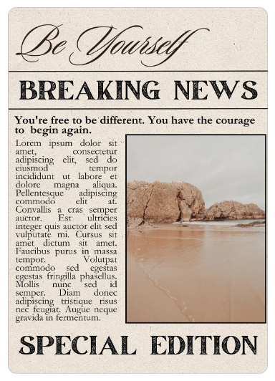
At the Top
YOUR CREATIVE HEADLINE
Your Subheading (what is going to draw in the reader?)
The By-Line: Your Name the Date
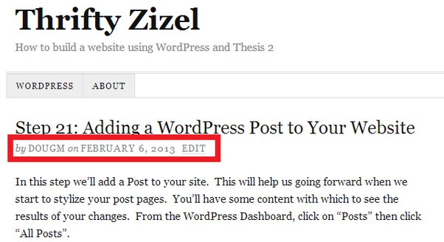
Lede (the 1st paragraph)
This is your Intro Paragraph, be sure to state the WHO/WHAT/WHERE/WHEN/WHY & HOW that will get your readers attention.
Body (the 2-3 paragraphs)
This is the meat of your article, give the facts, thoughts, quotes from at least 2 of your 3 sources. Who could be quoted as an expert or a witness? What did they say? Why is this a newsworthy topic.
Conclusion (the Last paragraph)
Summation of your article & leave the reader with a thought to think on, is this article hoping for change? Is it an update on a previous topic? Is there more information to come?.
Sources
Minimum of 3 FULL, APPROVED Sources, cannot all come from 1 source (like ESPN)
- https://transcripts.cnn.com/show/sn/date/2023-09-26/segment/01
Mini bio
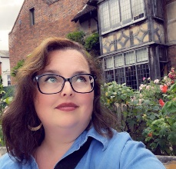
Robin Reed is an ELA Teacher, a mom, a traveler, and someone that loves to learn from all the aspects of her life-whenever possible! She has written multiple types of curriculums, as well as curating her life on social media. Follow along for more details in the life the modern teacher, manic mom of a teen & a 20-something, with the sassiest cat on the planet, and their weekly wonderings in this thing called life.
Final Submission Requirements: 250 words minimum (you can see your word count on the lower left of your Word Document)

